

|  |
| --- |
| AUTOMATIC TICKET ASSIGNMENT  AIML Online Capstone Group 6  05-Jul-20  Group 6 |

# Summary of problem statement, data and findings

## Problem Statement

Manual assignment of incidents is time consuming and requires human efforts. There may be mistakes due to human errors and resource consumption is carried out ineffectively because of the misaddressing. On the other hand, manual assignment increases the response and resolution times which result in user satisfaction deterioration / poor customer service.

## Abstract

Applying traditional machine learning and neural network-based NLP to automatically classify tickets and assign them to the right owner in a timely manner to save effort, increase user satisfaction and improve throughput in the ticketing pipeline of an organization.

## Solution Approach

We have used separate ipynb files for below:

1. All machine learning models
2. LSTM
3. Bi LSTM
4. GRU
5. Attention Layer

https://github.com/jayapavandeshpande/nlp_project/tree/NLP-Soumendra

## Data & Findings

1. The dataset comprises of **8500 rows** and **4 columns**
2. All columns are of type object containing textual information.
3. There are **8 null/missing values** present in the Short description and **1 null/missing values** present in the description column
4. **Password reset** is one of the most occurring tickets which reflects in the Short description column.
5. The top occurring Description in the dataset is only the text **'the'**, which absolutely doesn't make any sense. hence by looking at the Short description of such rows reveals that these are also a category of Password reset.

### Data provided in format

XLSX/CSV

### Total Records

8500

### Data Fields

|  |  |
| --- | --- |
| Short description | A summary of the issue faced by the user |
| Description | Detailed description of the issue |
| Assignment group | GRP_0 ~ GRP_73 (total 74 classes of Assignment group) |

### Sample data

| **Short description** | **Description** | **Assignment group** |
| --- | --- | --- |
| login issue | -verified user details.(employee# & manager na... | GRP_0 |
| outlook | \r\n\r\nreceived from: hmjdrvpb.komuaywn@gmail... | GRP_0 |
| cant log in to vpn | \r\n\r\nreceived from: eylqgodm.ybqkwiam@gmail... | GRP_0 |

### Distribution of classes and Observation

1. High imbalance seen in data for target column in our dataset with GRP_0 having highest percent of representation
2. Many classes with very little representation.
3. Null values in Data:
   1. Short description **8**
   2. Description **1**
   3. Assignment group **0**
4. Observed few Ticket having Non-English ticket descriptions

# Overview of the final process

1. Loaded the given dataset
2. Performed EDA on the dataset to identify the
   1. Distribution of data,
   2. Languages,
   3. Length of each column of dataset.
3. Perform pre-processing
   1. Replace email Ids
   2. Contractions
   3. Lemmatization
   4. Replace the gibberish text using FTFY
   5. Detect the language
   6. Translate the non English content to English using Azure API
4. Identify the deterministic rules using MS SQL and MS Excel
5. Apply Deterministic rules on Dataset to address the groups before modelling
6. Perform text summarisation
7. Perform Up sampling on complete dataset except Group 0.
8. Perform Clustering on Group 0 records alone
9. Combine both the Up sampled and clustered data frames
10. Define independent and dependent features
11. Perform Label Encoding on dependant feature (target column)
12. Perform Vectorisation on independent features using TF-IDF/Tokenizer
13. Split the data to train and test dataset in 70:30 ratio
14. Apply Machine Learning models
    1. Support Vector Machine (SVM)
    2. Naïve Bayes Classifier
    3. Random Forest
    4. Light GBM
15. Apply Deep learning models
    1. LSTM
    2. Bi directional LSTM
    3. RNN
    4. Attention
16. Identify the best model based on the predictions

# Step-by-step walk through the solution

## Load Dataset

Loaded the input csv file into pandas data frame

## EDA on dataset

1. Distribution of data
2. Identified the languages
3. Most common words
4. Top n words
5. Bi grams
6. Trigrams

## Pre-Processing

1. Treating the missing values using Rake Algorithm: Rake extract Key phrases in a body of text by analysing the frequency of word appearance and its co-occurrence with other words in the text.

We are finding similar rows based upon identical Rake values and replacing the missing NaN values.

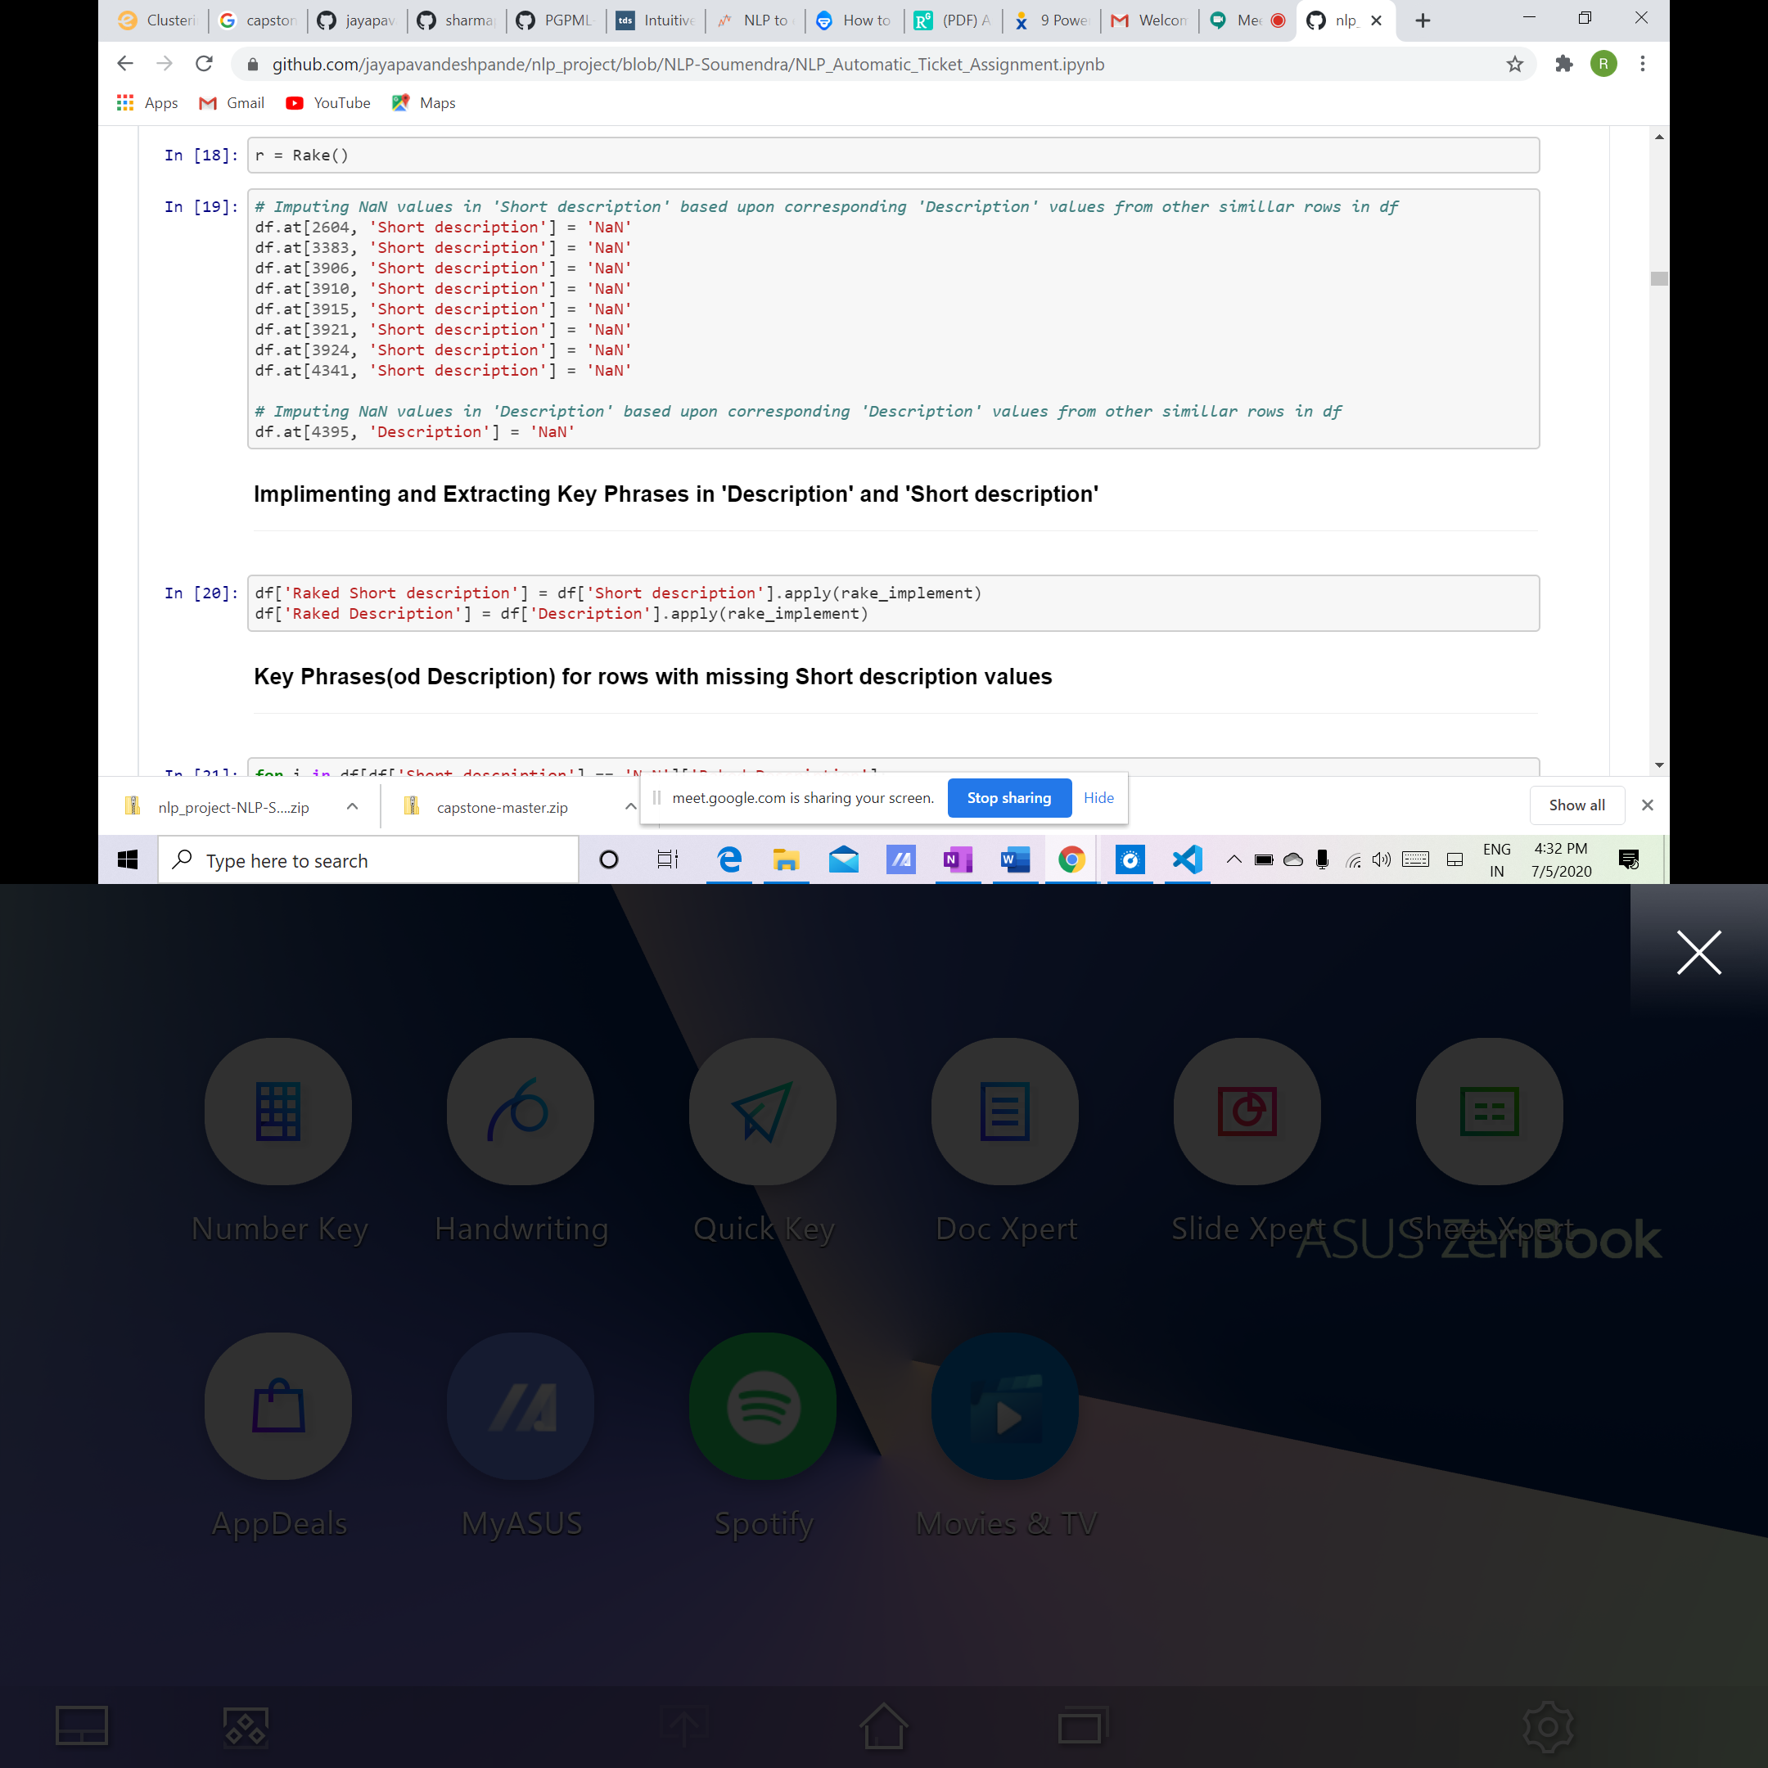

1. Replace email Ids – Email Ids of users are replaced with common text ‘Email Address’ from Description and Short Description as it does not hold any significance.
2. Expanded all contractions as this is an important step, because it will reduce disambiguation between similar phrases
3. Grouped together the different inflected forms of a word using NLTK Lemmatization so they can be analysed as a single item
4. Used Regex Library for removal of
   1. Trailing spaces,
   2. line breaks and tabs (\r\n\t),
   3. Special characters and
   4. Extra spaces.
   5. Convert the data having garbled text such as mojibake using Ftfy Library.

## Foreign language detection and translation

1. Identified around 28 languages - For language identification, we used Facebooks's fastText library which can recognize more than 170 languages and classify thousands of documents per second.
2. The model returns back two tuples back. ISO code and the confidence level. # ([['_label_de']], array([[0.96568173]]))
3. For converting the ISO code to language name we used pycountry library. eg: de --> German
4. Translated using
   1. Goslate
   2. Google Translate API and
   3. Azure APIs
5. Identified better translation accuracy using Google/Azure translator (translate 3.5.0) which uses Microsoft Translation API, a cloud-based machine translation service that extends the reach of apps in more than 60 languages
6. To the save number of hits to API, we have saved the already translated dataframe into csv file and reusing it in our project.

## Deterministic Rules

Our objective for using the deterministic rule is to identify and remove some of the groups which can be easily predicted by these rules and hence can be bypassed before feeding data into any kind of ML/DL Models.

Another added advantage is it will remove many GRP labels from Assignment group feature that have only one row/record which are not enough to train models on them.

Deterministic rules are fixed set of rules /conditions that provide an accurate match on given dataset.

The dataset provided is having 74 groups and the data distribution is not balanced. The likelihood of predicting the accurate group may vary using a ML model due to this imbalance and may cause over fitting.

To eliminate this problem, we have selected the classes with less than 20 samples and tried to identify the similarities to accurately identify each of these classes.

We have queried the data for similarities within each class by loading data into Excel and SQL. We were successfully able to identify rules to predict 12 classes completely and 4 classes partially.

The deterministic rules are applied on the translated data set. The predicted samples are assigned a 'predicted group' as a new column in dataset.

When we evaluated model performance, we found that the dataset on which deterministic rule is not implemented is giving more accuracy. This step is excluded in the final project.

## Text Summarisation

Summarization aims to highlight important information within a large corpus. We have used Gensim summarization on our dataset

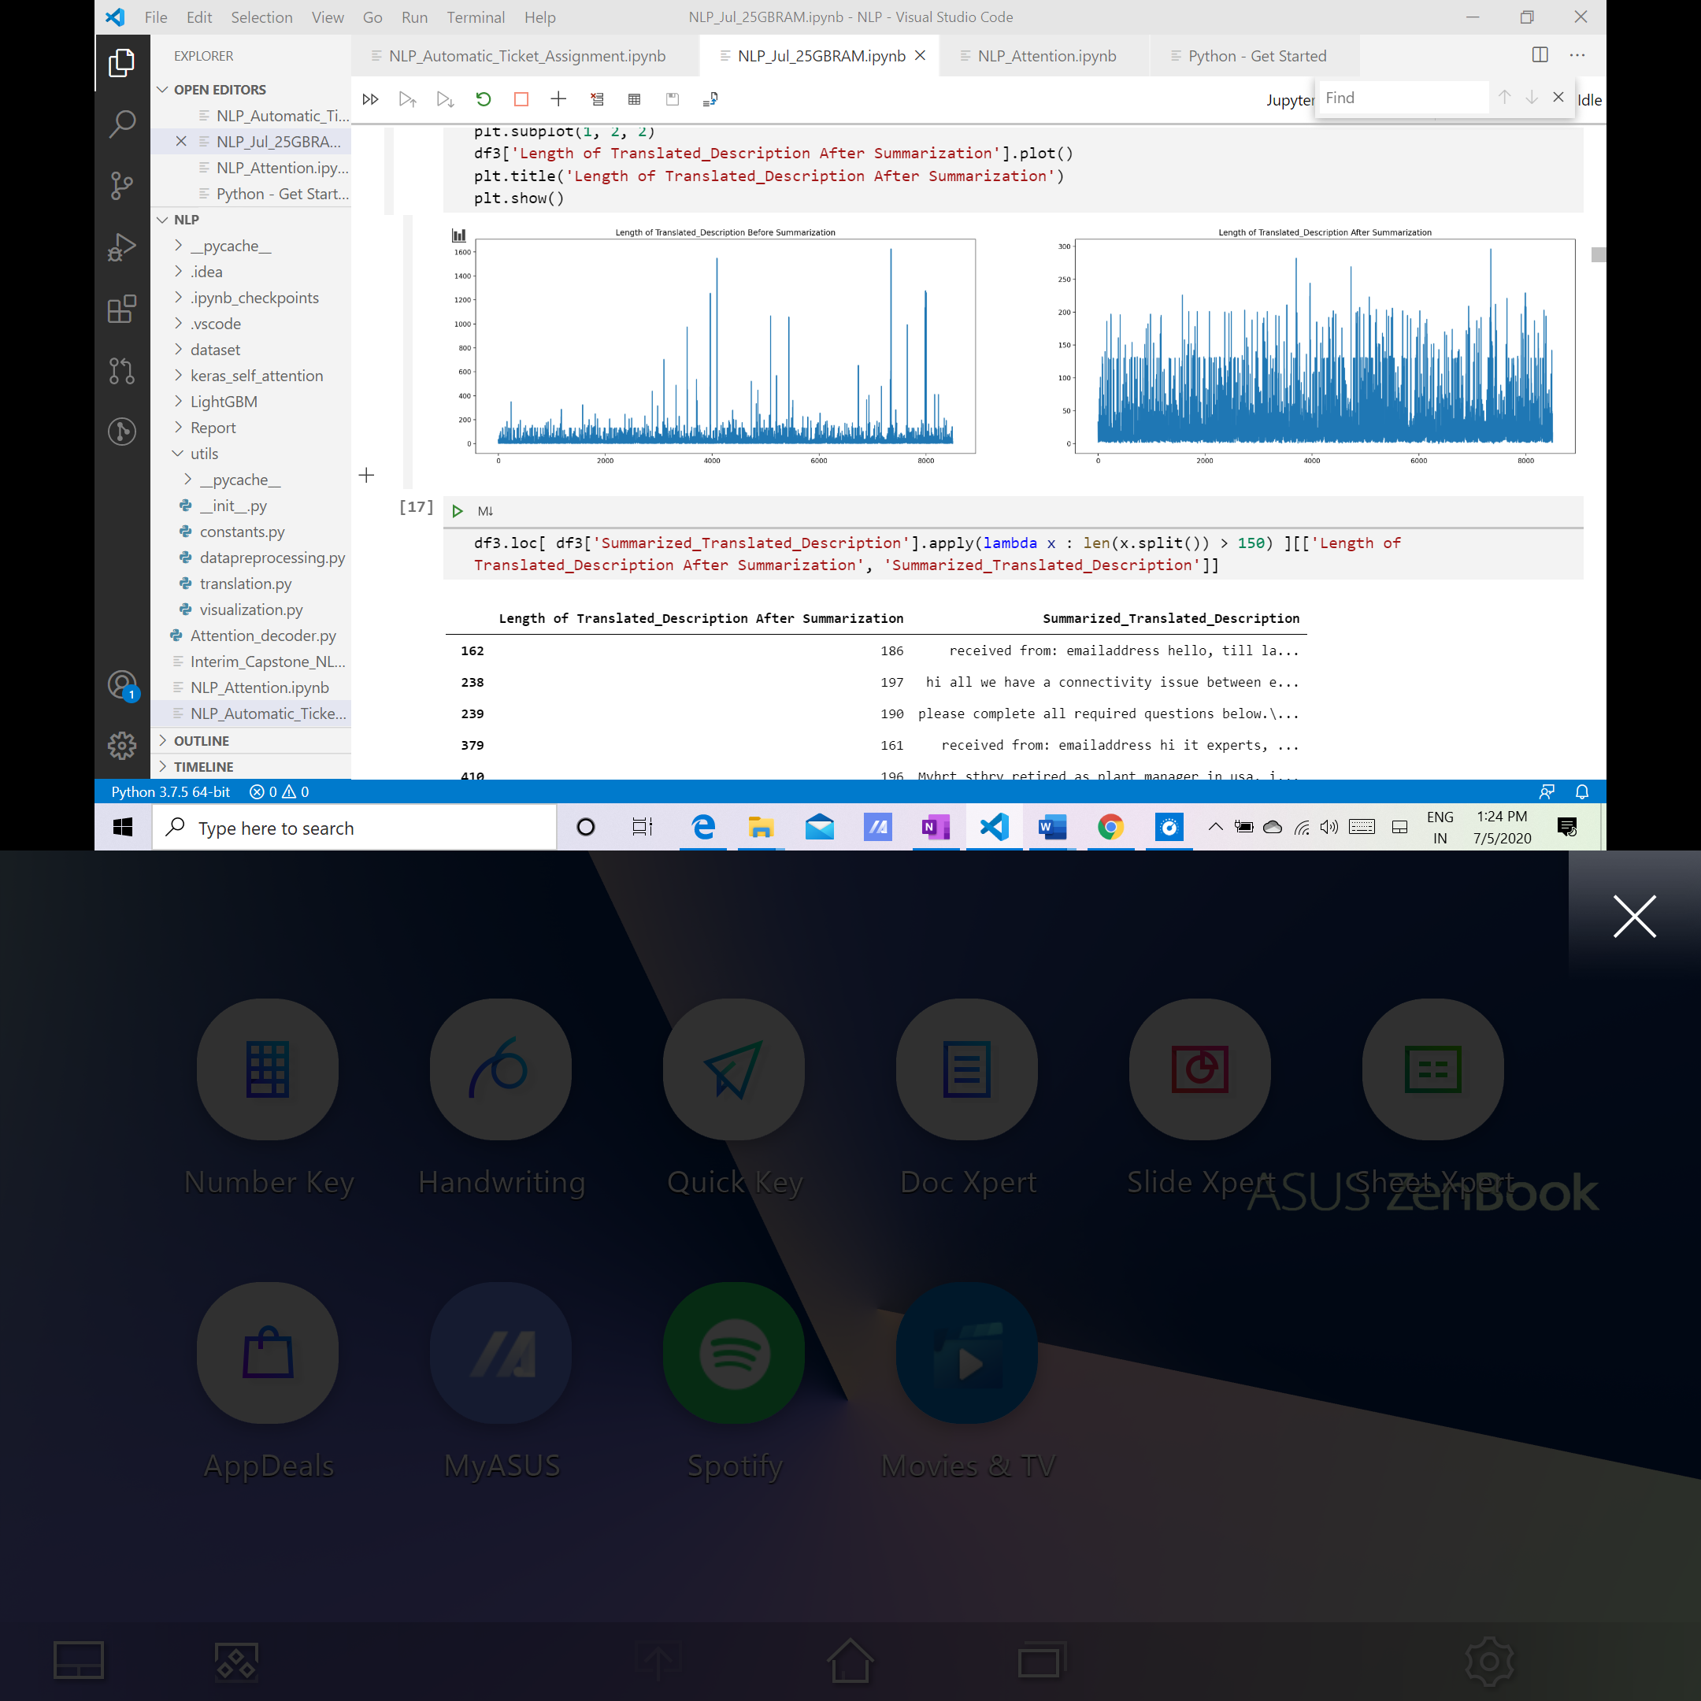

## Up sampling

Imbalanced datasets are those where there is a severe skew in the class distribution, such as 1:100 or 1:1000 examples in the minority class to the majority class.

This bias in the dataset can influence many machine learning algorithms, leading some to ignore the minority class entirely. This is a problem as it is typically the minority class on which predictions are most important.

One approach to addressing the problem of class imbalance is to randomly resample the dataset. The two main approaches to randomly re sampling an imbalanced dataset are

* 1. Deleting samples from the majority class known as under sampling, and
  2. Duplicating samples from the minority class, known as Over sampling.

In our case, we are not considering under sampling as it would result in loss of data. Instead we have used up sampling using Random oversampling technique.

We are passing the cleaned data set excluding the majority class (GRP_0) to this over sampler. We were able to up sample 4524 minority class records (input) to 48253 records (output).

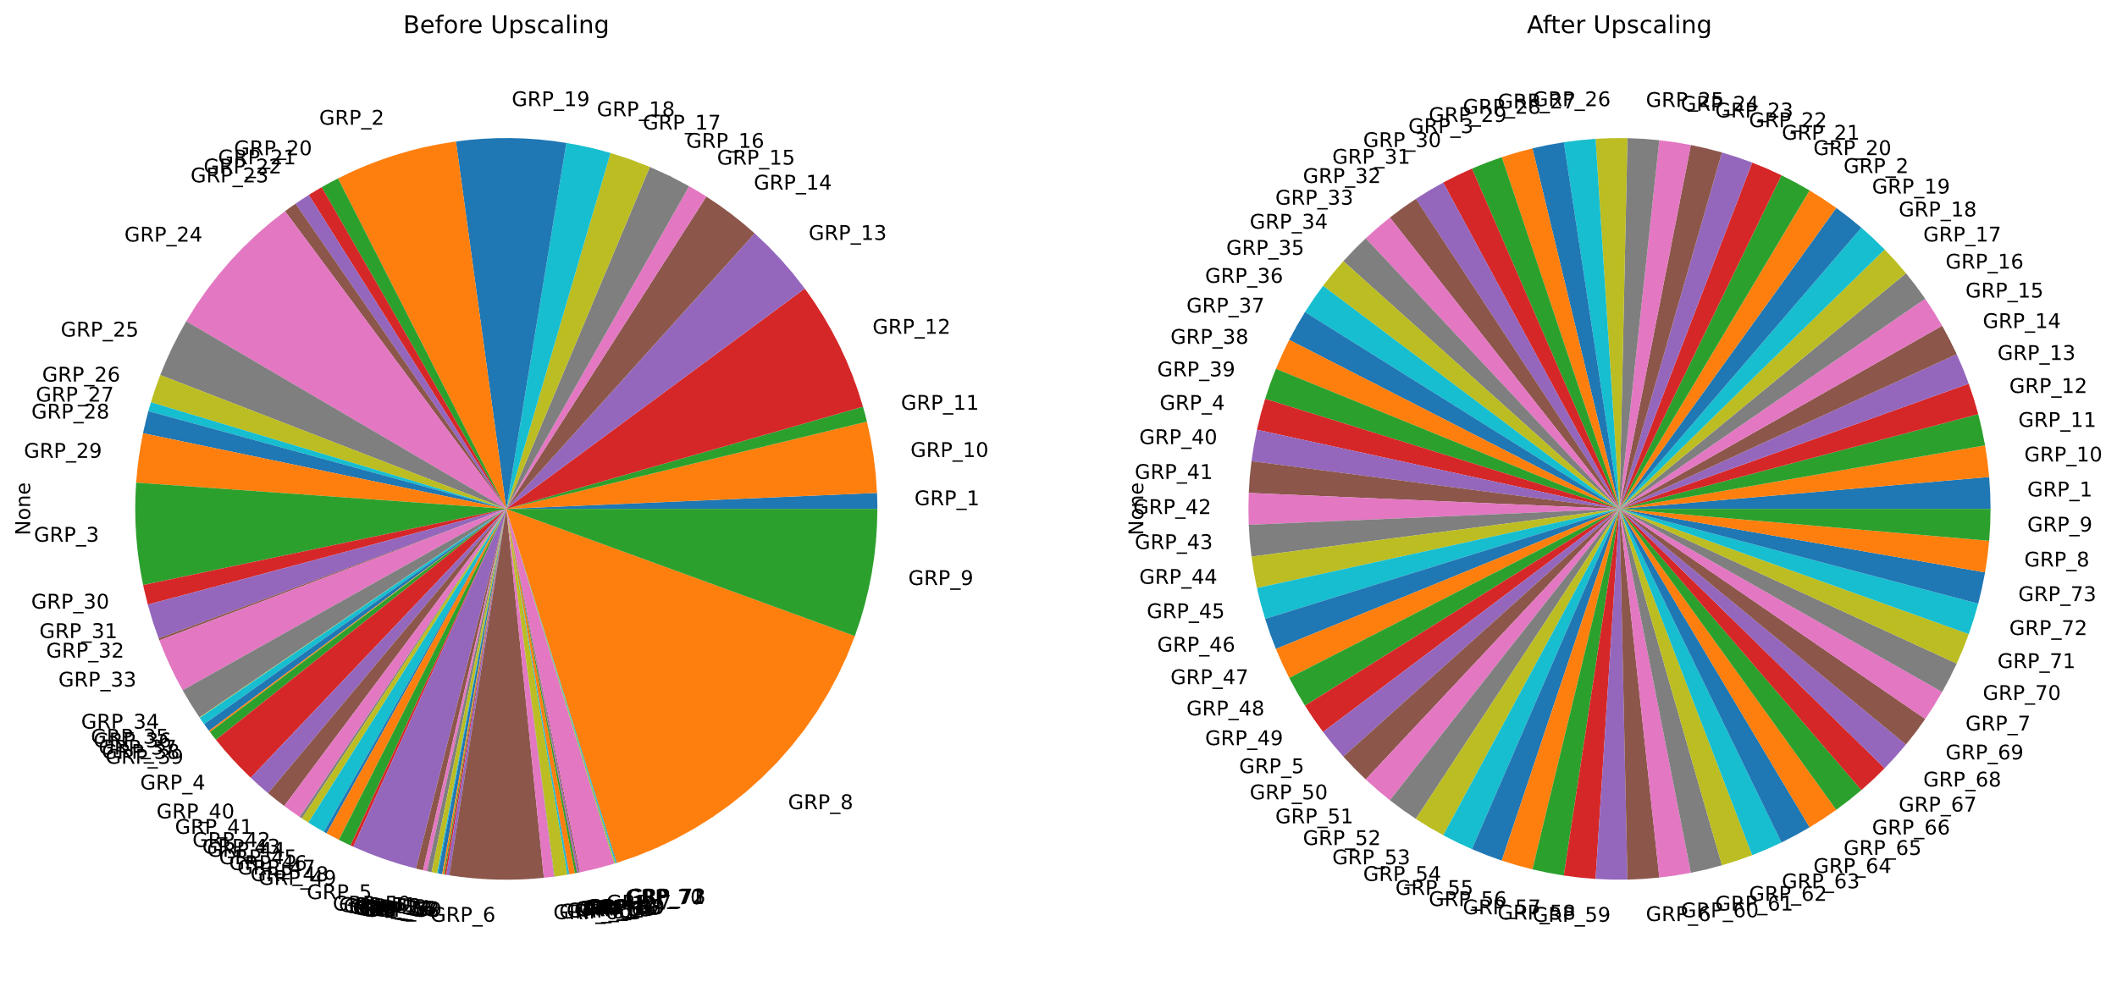

## Clustering

During our analysis we noticed that GRP_0 has around 3976 records out of 8500 records and have different category of issues mapped within the same group. In order to identify the similar categories and map to the subgroups we explored various clustering techniques and finalized K-means clustering which is an unsupervised clustering algorithm which determines the optimal number of clusters using the elbow method. It works iteratively by selecting a random coordinate of the cluster centre and assign the data points to a cluster. It then calculates the Euclidean distance of each data point from its centroid and based on this, it updates the datapoint positions as well as the cluster centres.

For finding the optimum number of centroids, the ‘elbow method’ is used. In it, the SSE value (sum of squared error) is calculated for different values of k (i.e no. of clusters) by clustering the dataset following each value of k. The point on the graph where a ‘hinge’ occurs is considered to be the optimal value of k (below figure) shows the elbow method for k means algorithm. Thus, by looking at the graph, the total number of clusters is found to be 8.

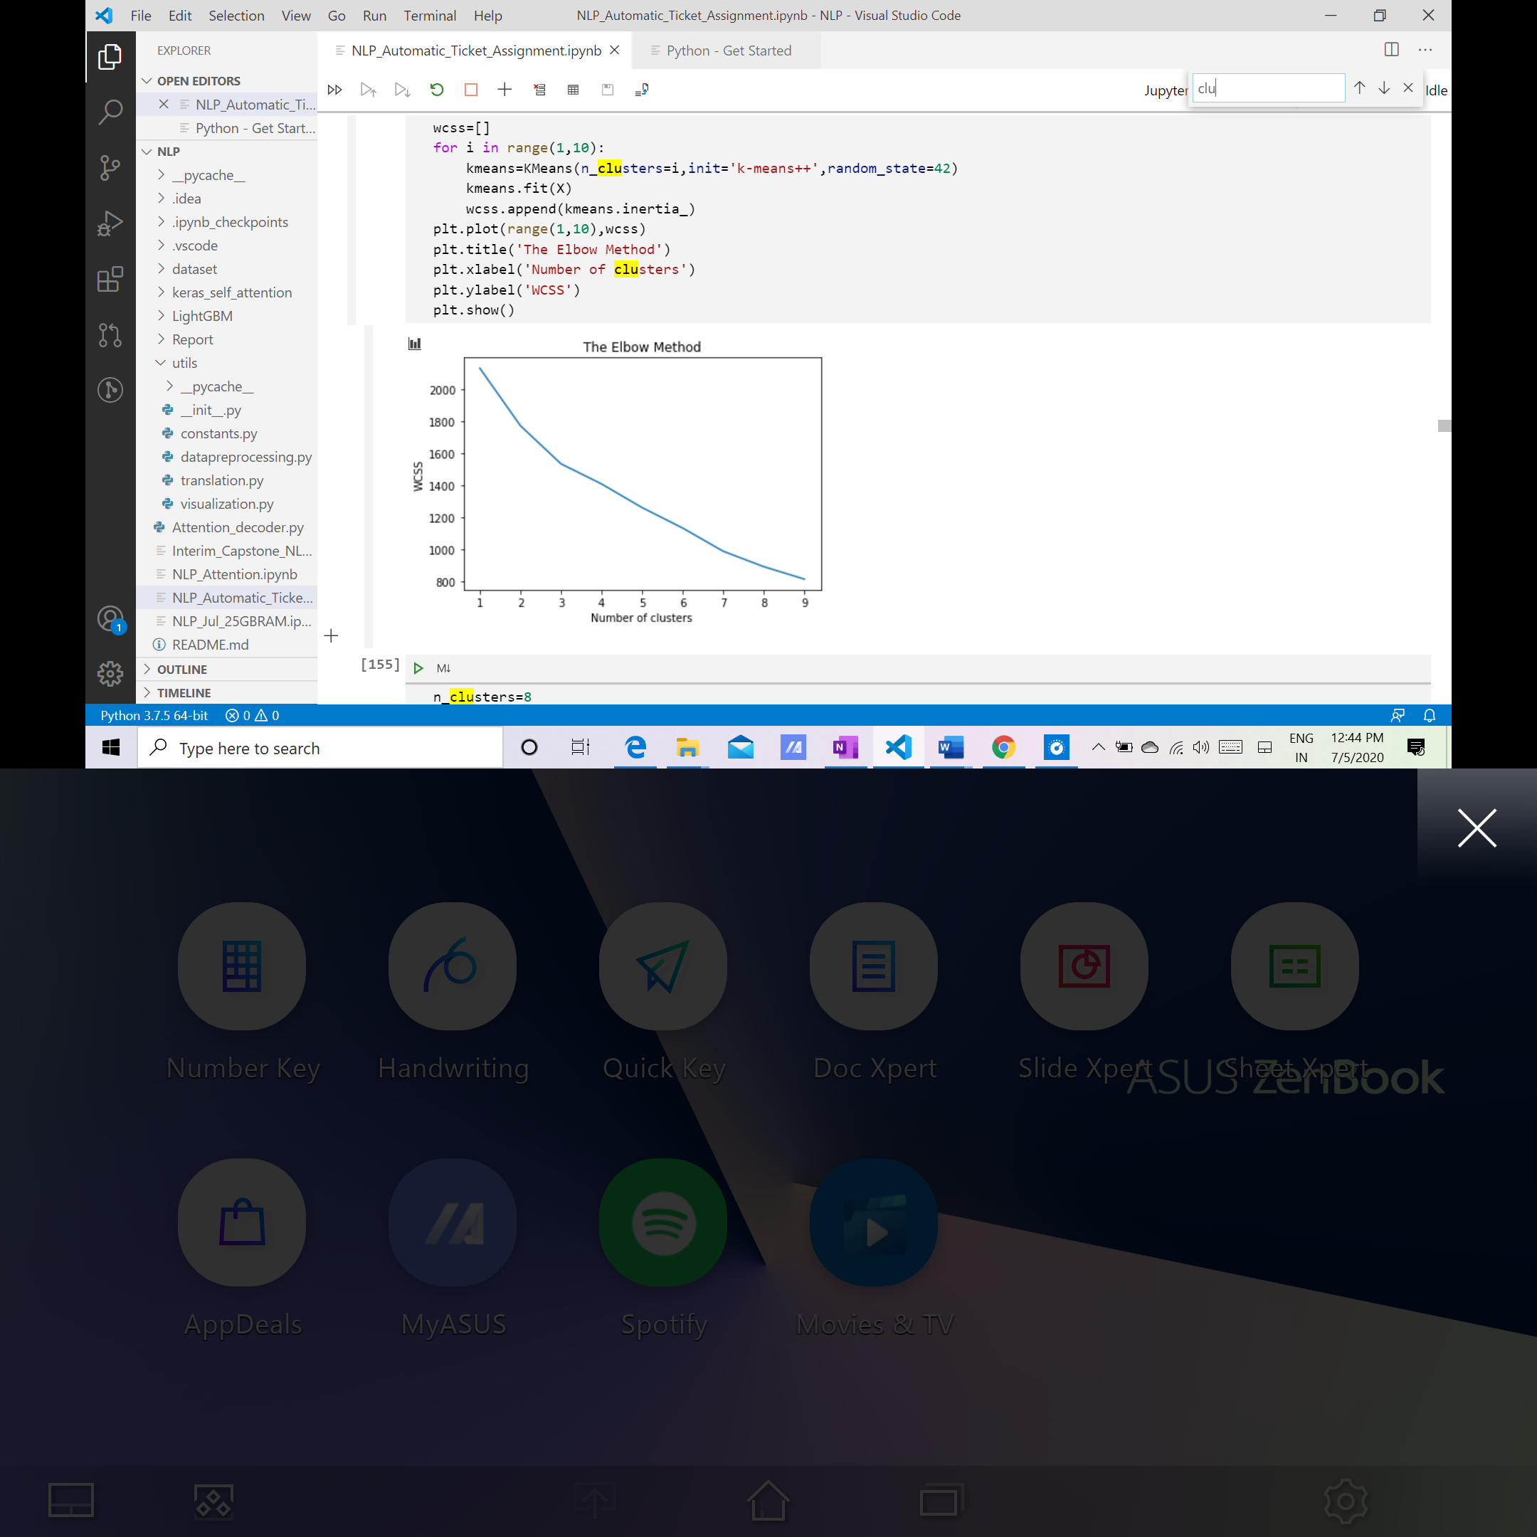

Since we can get any clear and prominent elbow, we are opting for a high value of cluster i.e. 8 because our objective is to divide the GRP_0 into maximum numbers of possible subgroups so that the individual group counts of the subgroups will be small.

Using the cluster numbers obtained from the elbow method, we use the k-means algorithm to predict the labels. Below is the data clustered as per the labels.

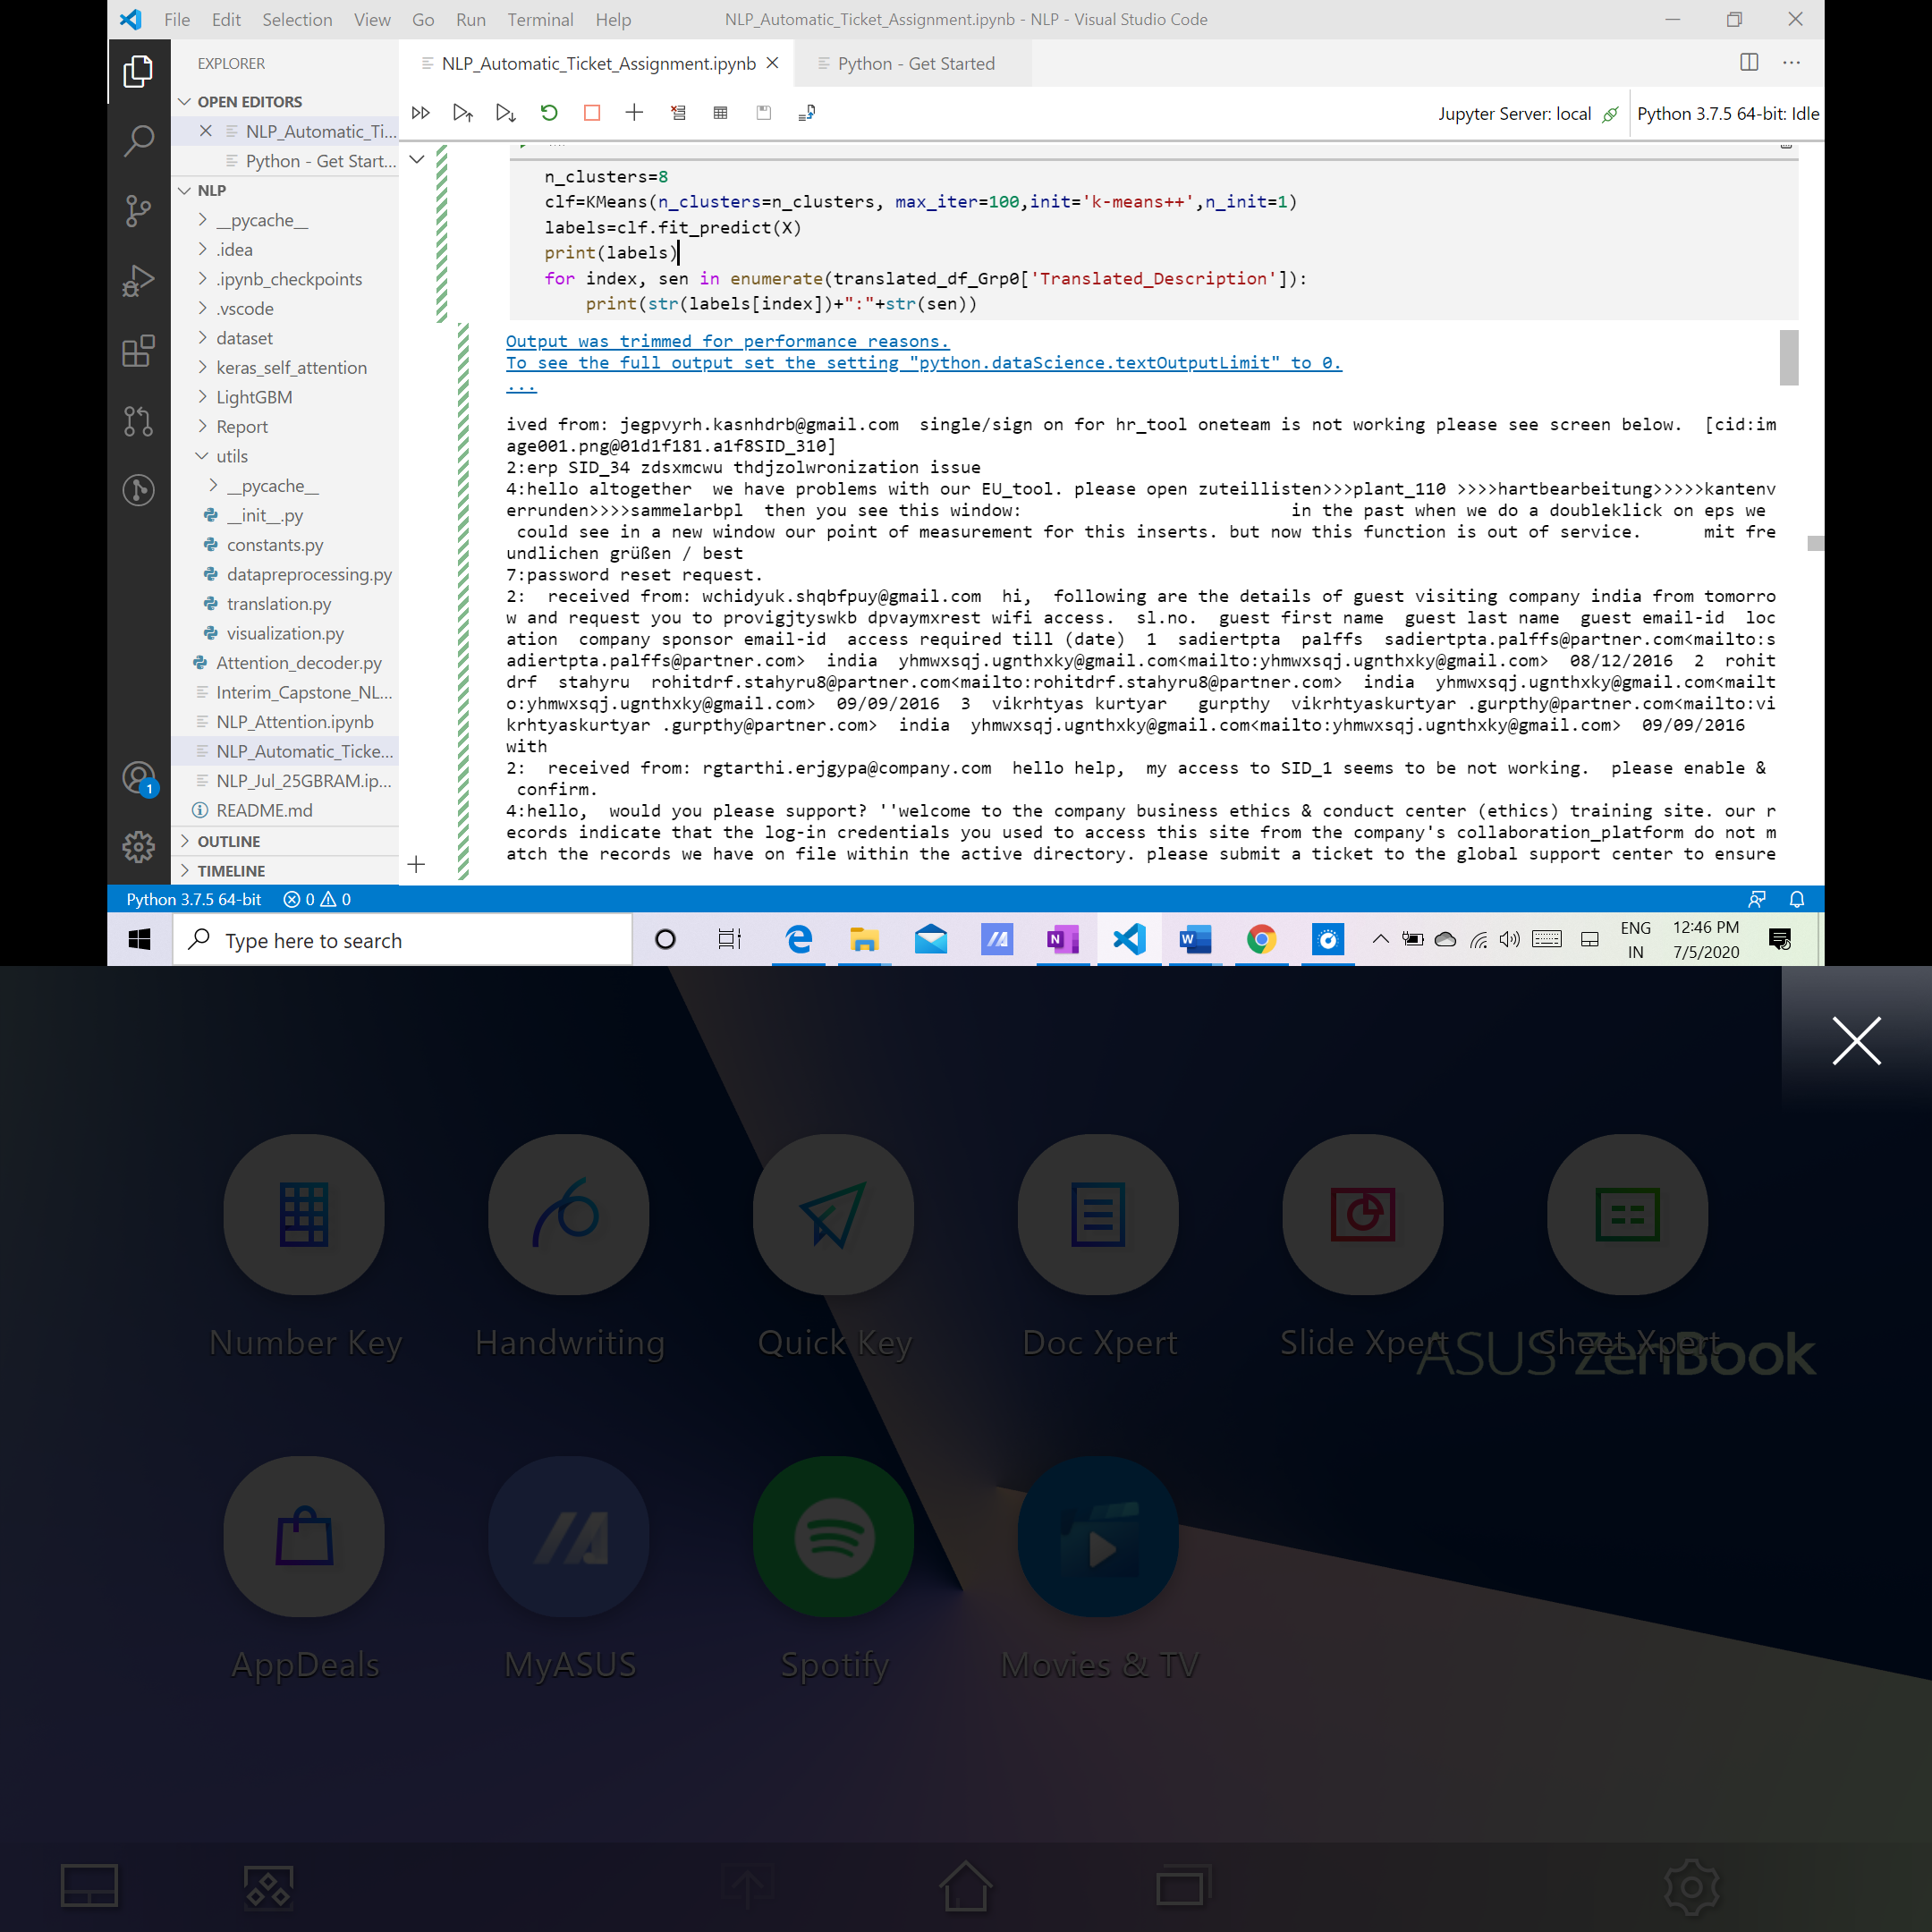

We used PCA to plot the clusters and to indicate the centre of the cluster we labelled them as “x”

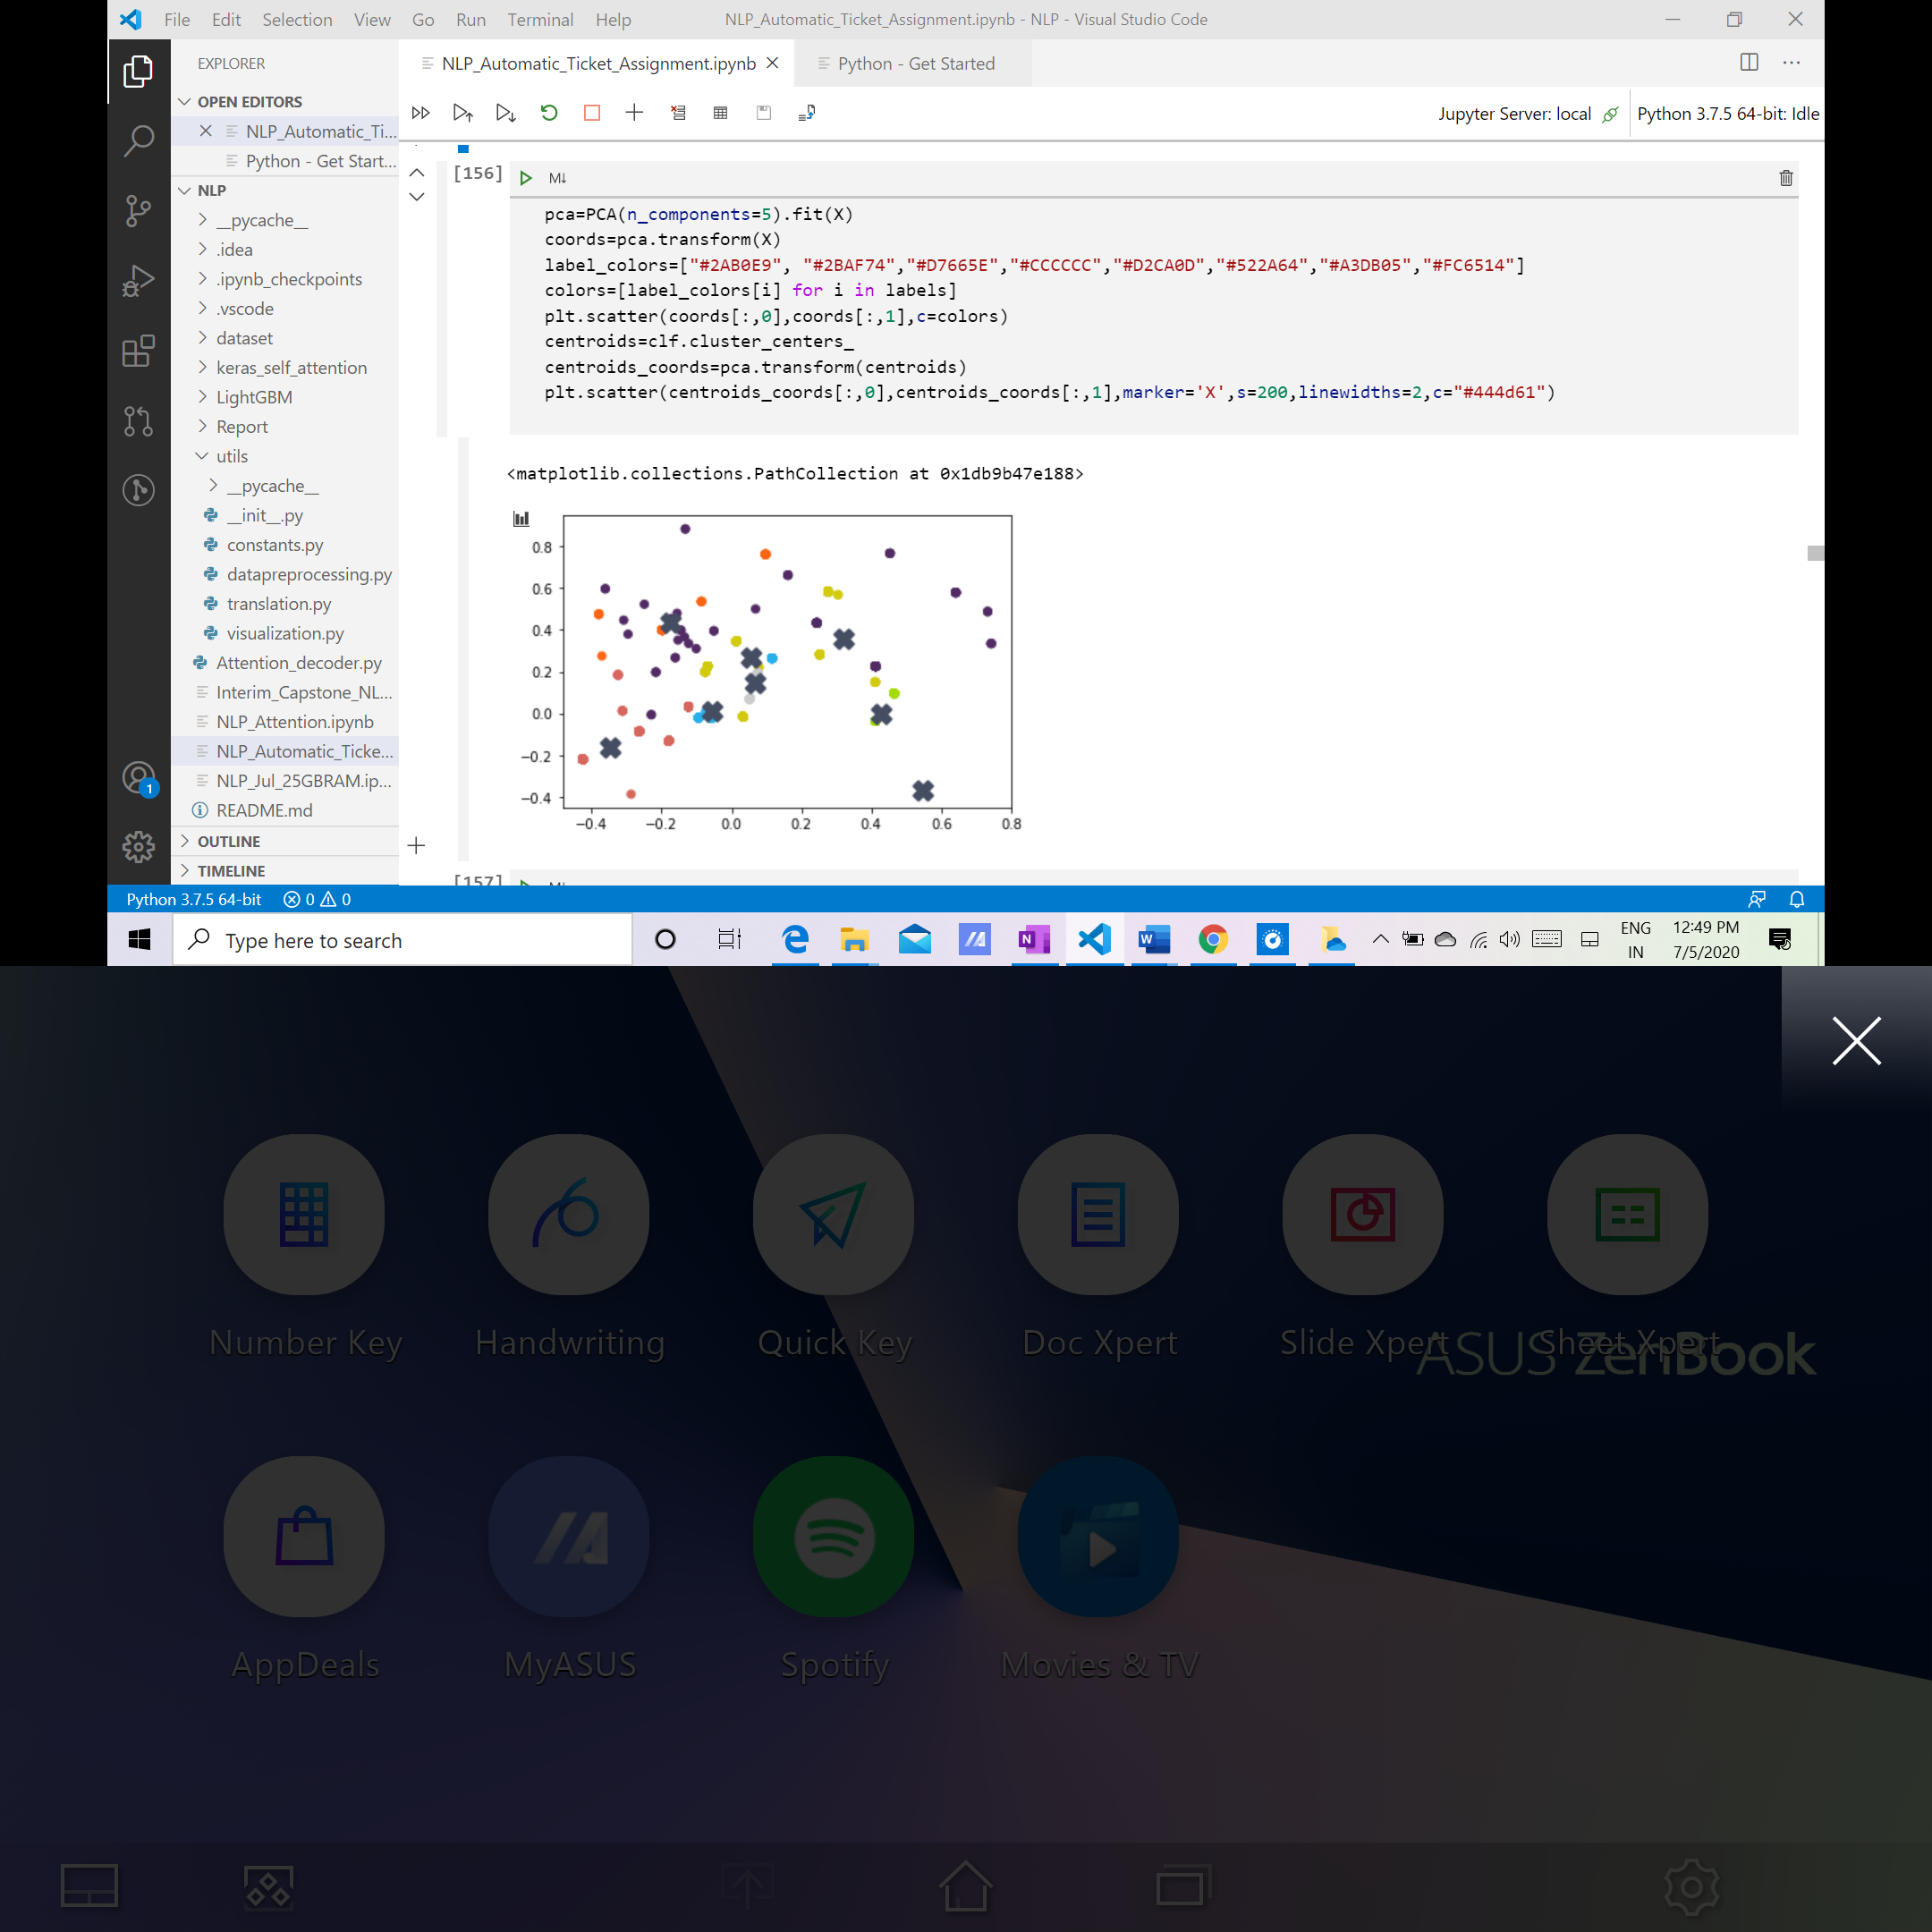

Based on the identified labels we categorized Grp_0 data into sub groups as depicted below:

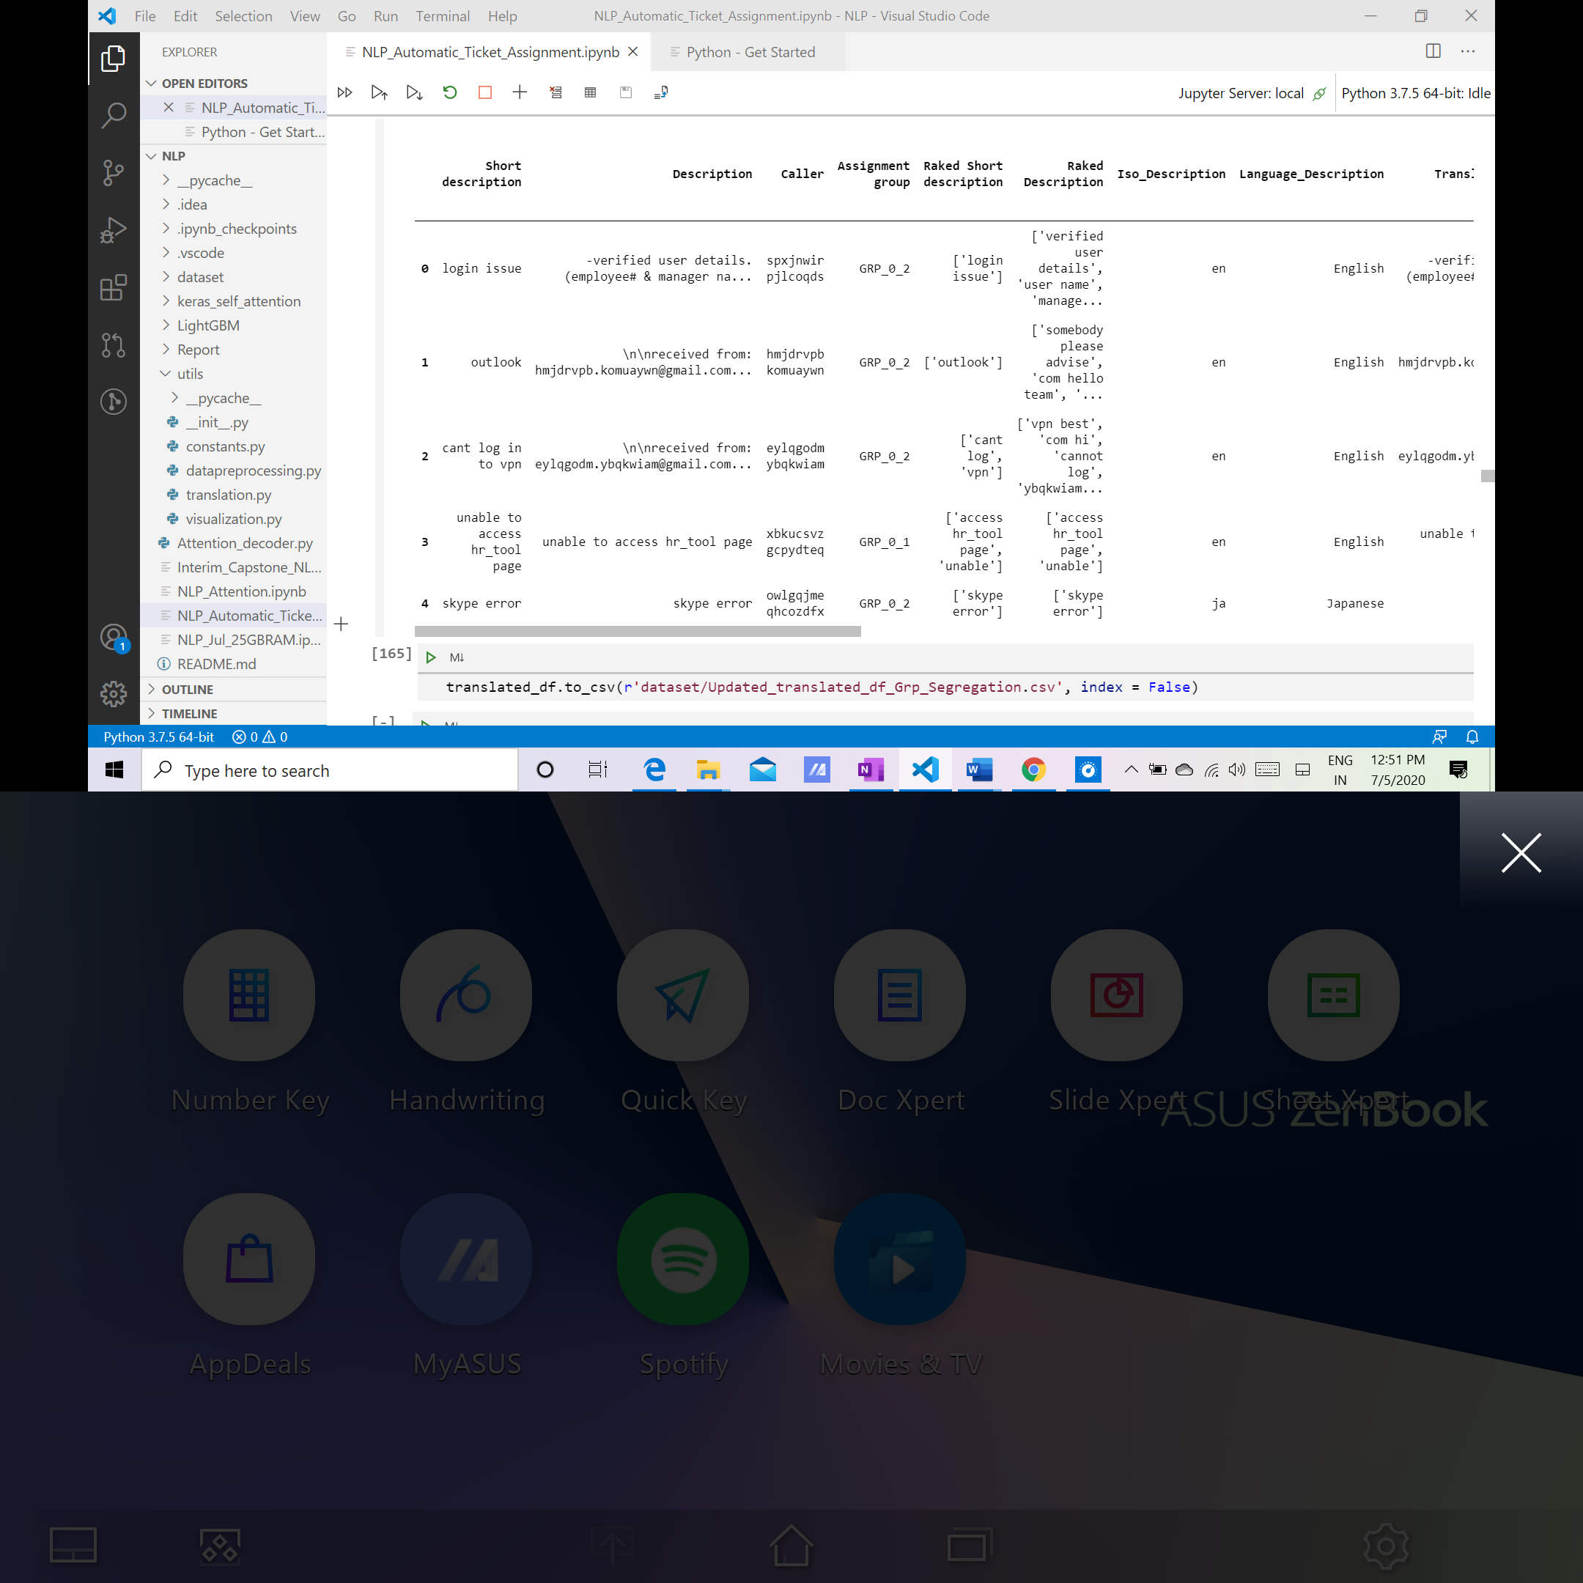

Below are the group labels identified using clustering:

['GRP_0_1', 'GRP_0_0', 'GRP_0_6', 'GRP_0_2', 'GRP_0_5', 'GRP_0_4', 'GRP_0_7', 'GRP_0_3']

## Define independent and dependent features

We are concatenating the Short description and Description as “Complete_Description”.

“Complete_Description” is considered as ***Independent attribute*** and Target – “Assignment group” is ***Dependent attribute***.

## Label Encoding

Labels in Target (Dependent) column are encoded using sklearn Label Encoder. SkLearn Label Encoder encodes target labels with value between 0 and n_classes-1.

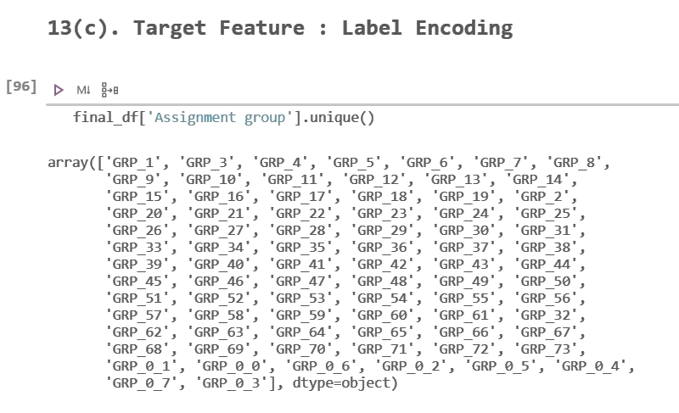

## Vectorization

Vectorization is used to score the relative importance of words. This can be done by either using TF-IDF or Keras Tokenizer and BoW.

### TF-IDF

Term Frequency (TF) is the number of times a word appears in a document divided by the total number of words in the document.

Inverse Data Frequency (IDF) is the log of the number of documents divided by the number of documents that contain the word w. Inverse data frequency determines the weight of rare words across all documents in the corpus

TF-IDF is the TF multiplied by IDF.

### BoW

In this model, a text (such as a sentence or a document) is represented as the bag (multiset) of its words, disregarding grammar and even word order but keeping multiplicity.

### Tokenizer

This class allows to vectorize a text corpus, by turning each text into either a sequence of integers (each integer being the index of a token in a dictionary) or into a vector where the coefficient for each token could be binary, based on word count, based on tf-idf.

## Splitting Datasets

We have used the train_test_split function for splitting a single dataset into training and testing in 70:30 ratios.

The testing subset is for building the model. The testing subset is for using the model on unknown data to evaluate the performance of the model.

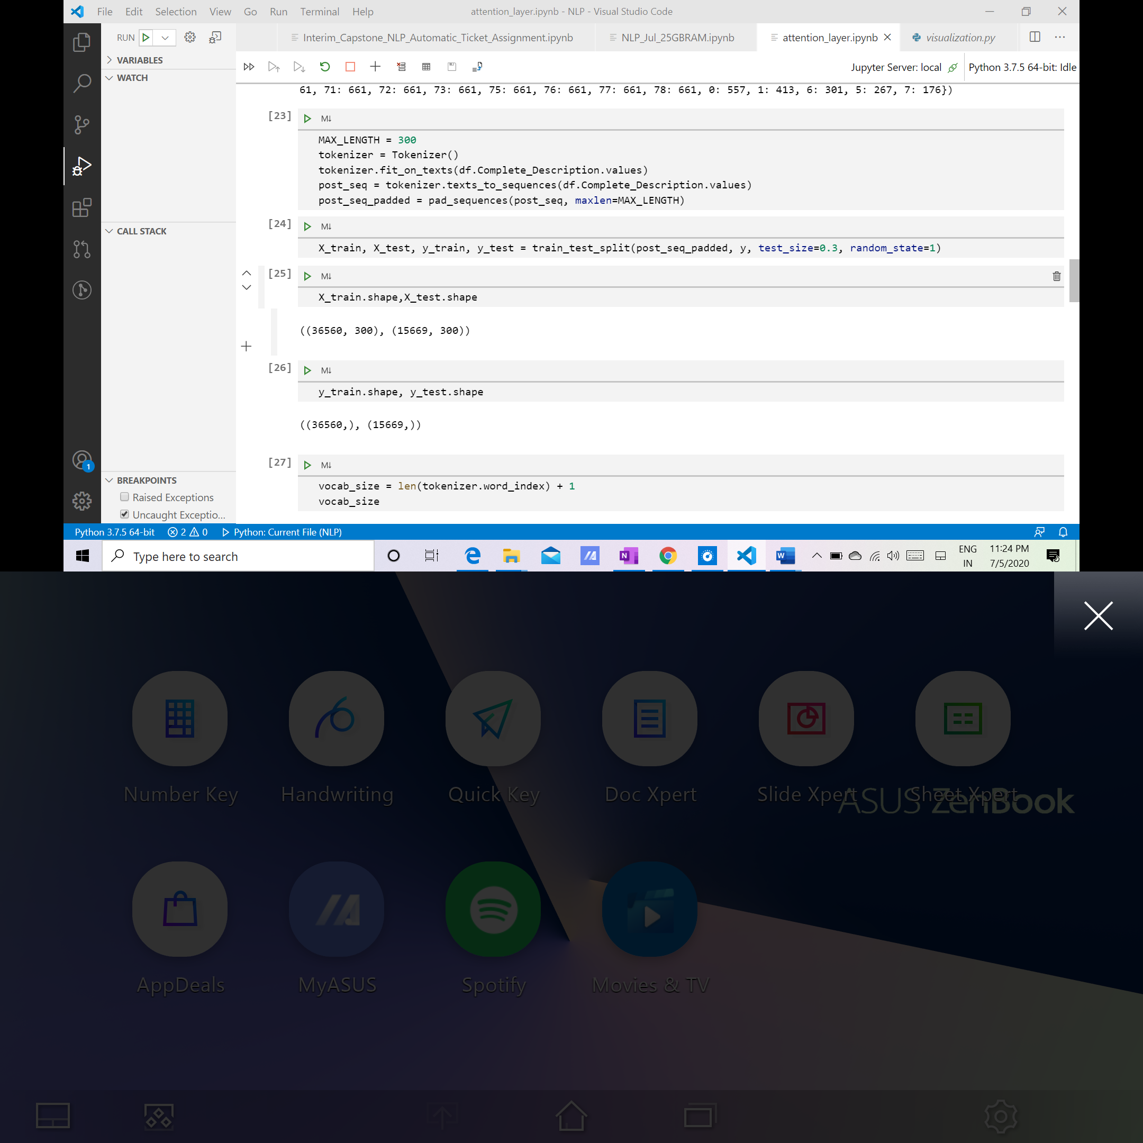

## Machine Learning Models

### Support Vector Machine (SVM)

The Support Vector Machine (SVM) algorithm is a popular machine learning tool that offers solutions for both classification and regression problems.

In addition to performing linear classification, SVMs can efficiently perform a non-linear classification using what is called the kernel trick, implicitly mapping their inputs into high-dimensional feature spaces.

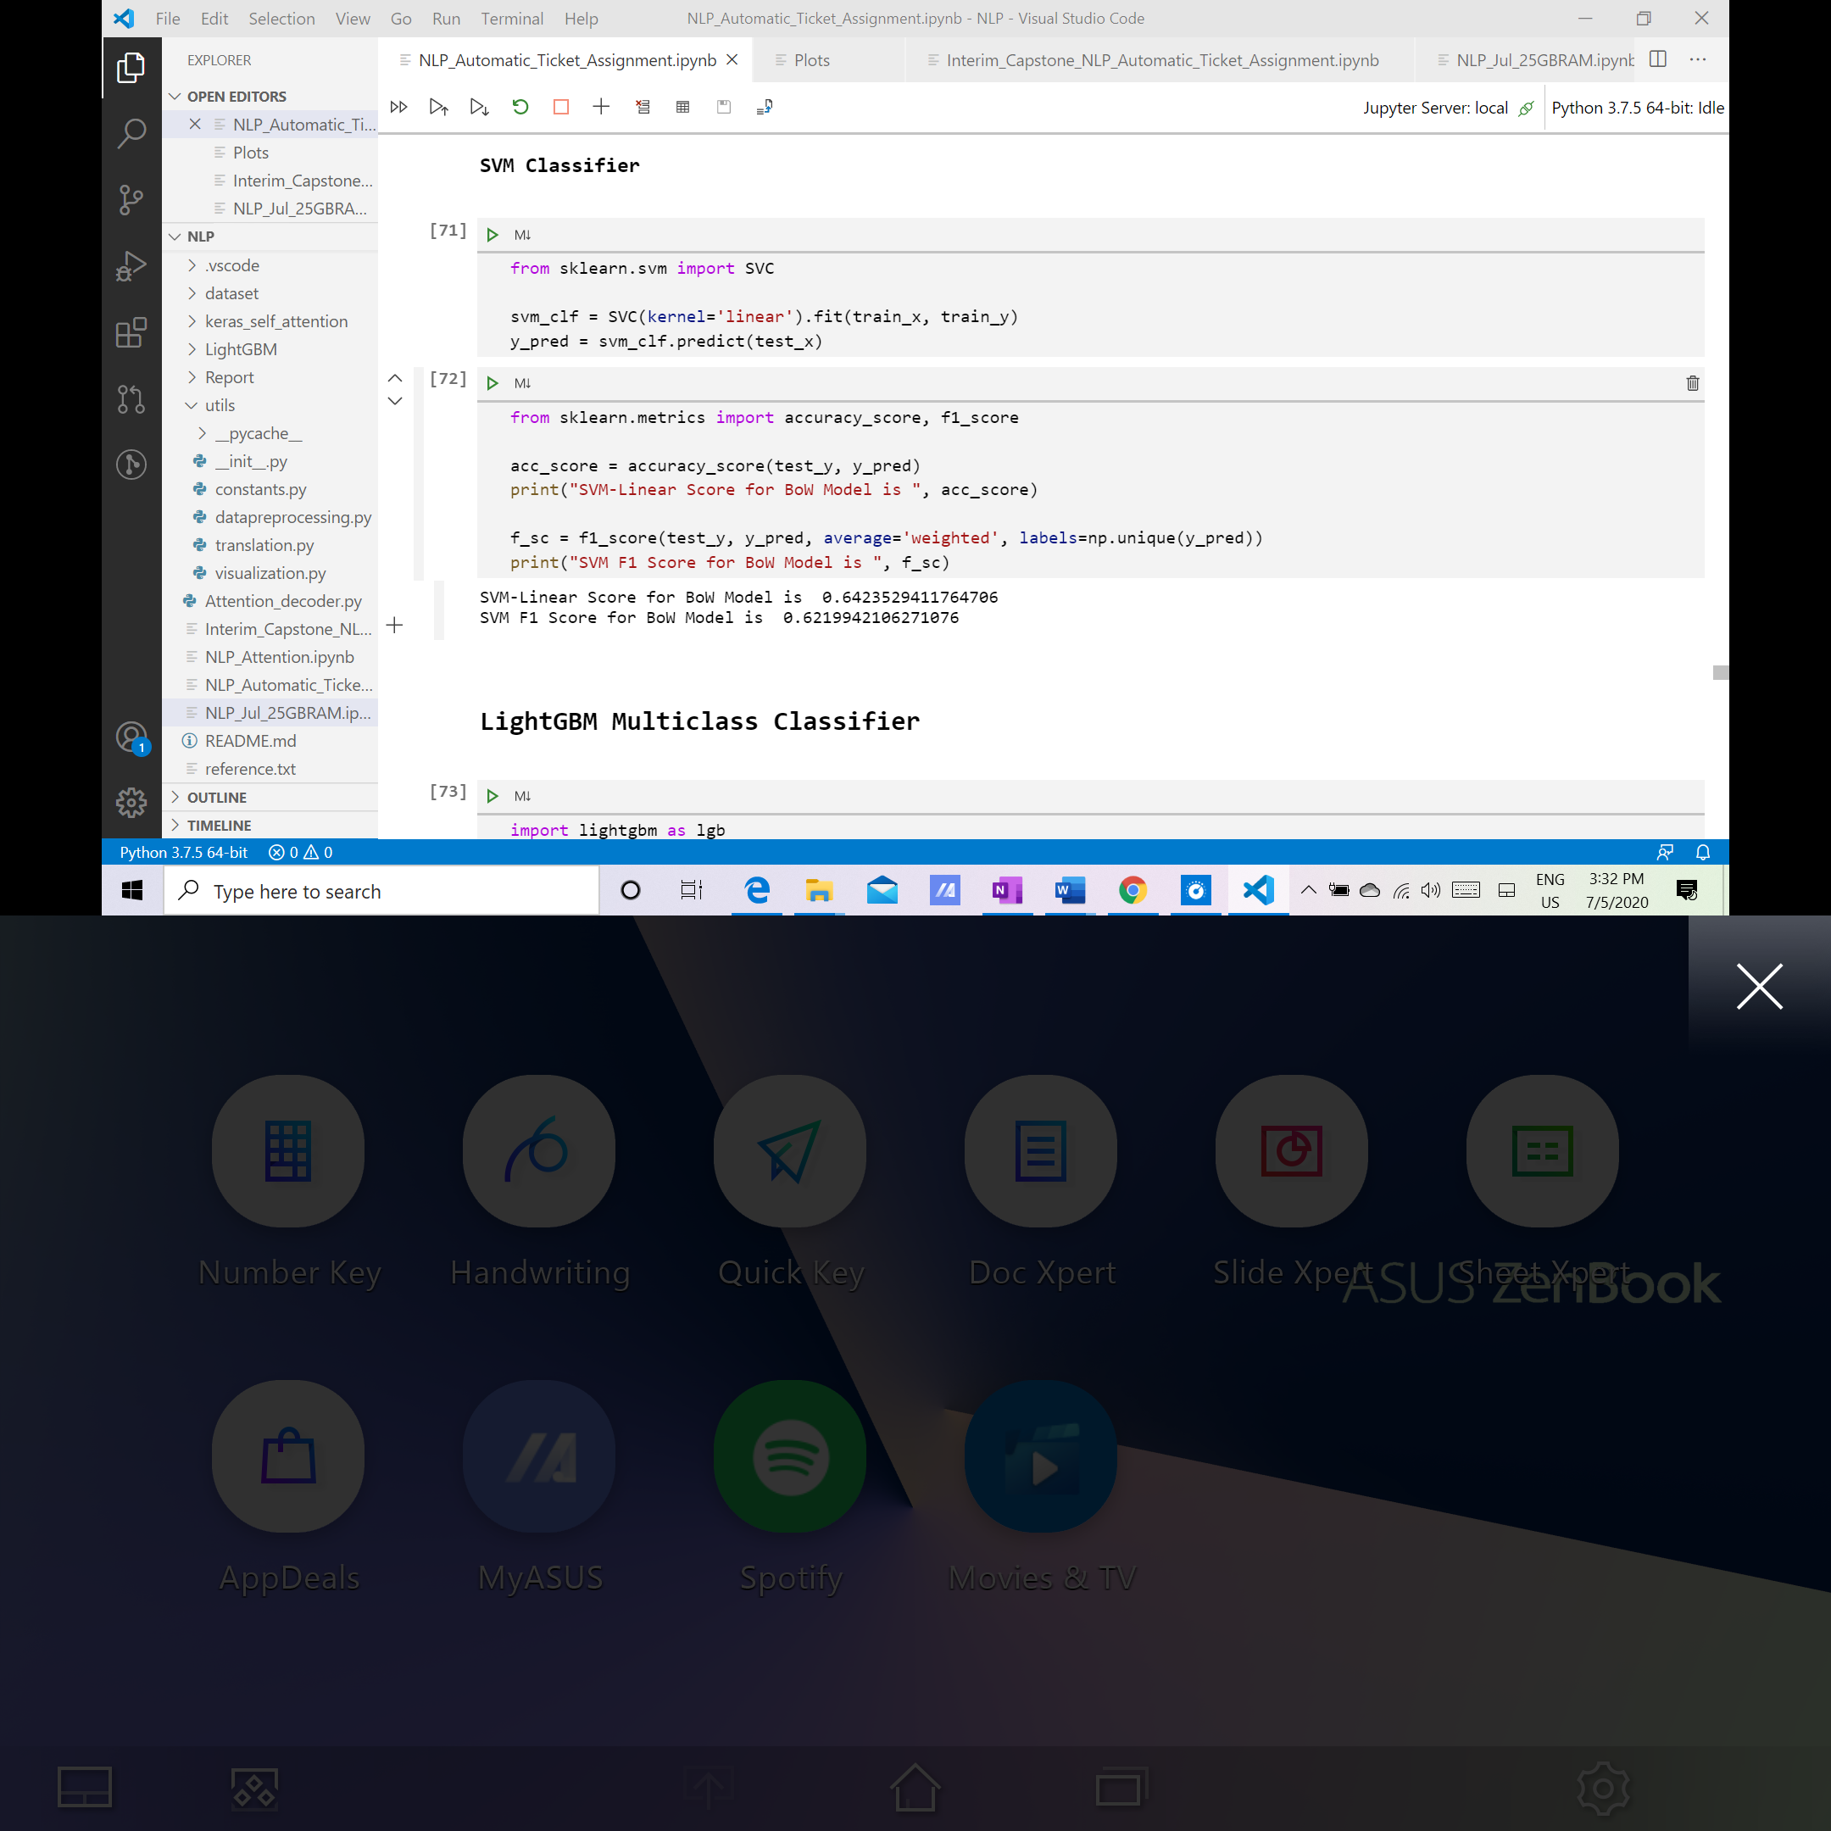

### Light GBM

LightGBM uses histogram-based algorithms which helps in speeding up training as well as reduces memory usage. This algorithm constructs trees leaf-wise in a best-first order due to which there is a tendency to achieve lower loss.

**We tried Random forest and Naives bayes algorithims for prediction but the results were significantly inferior. Hence, we dropped these algorithms to save run time of the project**.

## Deep Learning Models

### LSTM

Long short-term memory (LSTM) is an artificial recurrent neural network (RNN) architecture used in the field of deep learning. Unlike standard feedforward neural networks, LSTM has feedback connections. It can not only process single data points (such as images), but also entire sequences of data (such as speech or video).

**Model Summary:**

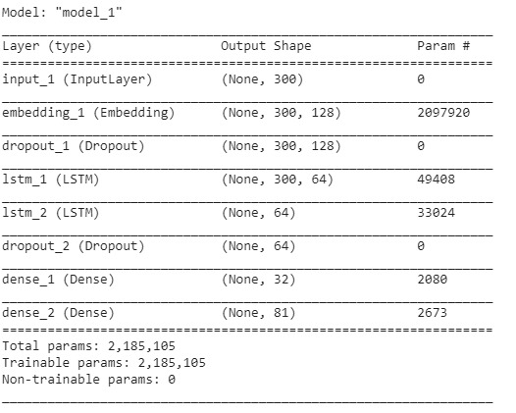

**Model Performance:**

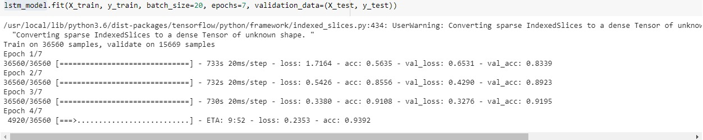

### Bi-Directional LSTM

Bidirectional RNN (BRNN) duplicates the RNN processing chain so that inputs are processed in both forward and reverse time order. This allows a BRNN to look at future context as well.

**Model Summary:**

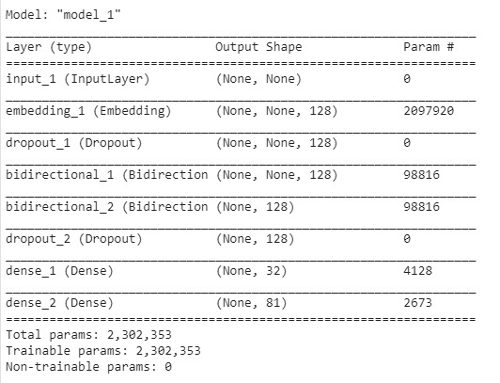

**Model Performance:**

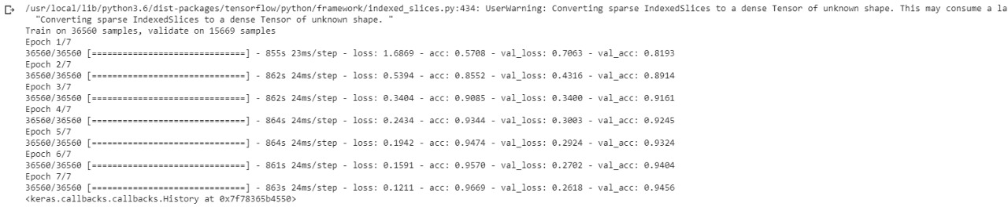

### GRU

A gated recurrent unit (GRU) is a gating mechanism in recurrent neural networks (RNN) similar to a long short-term memory (LSTM) unit but without an output gate. GRU’s try to solve the vanishing gradient problem that can come with standard recurrent neural networks.

**Model Summary:**

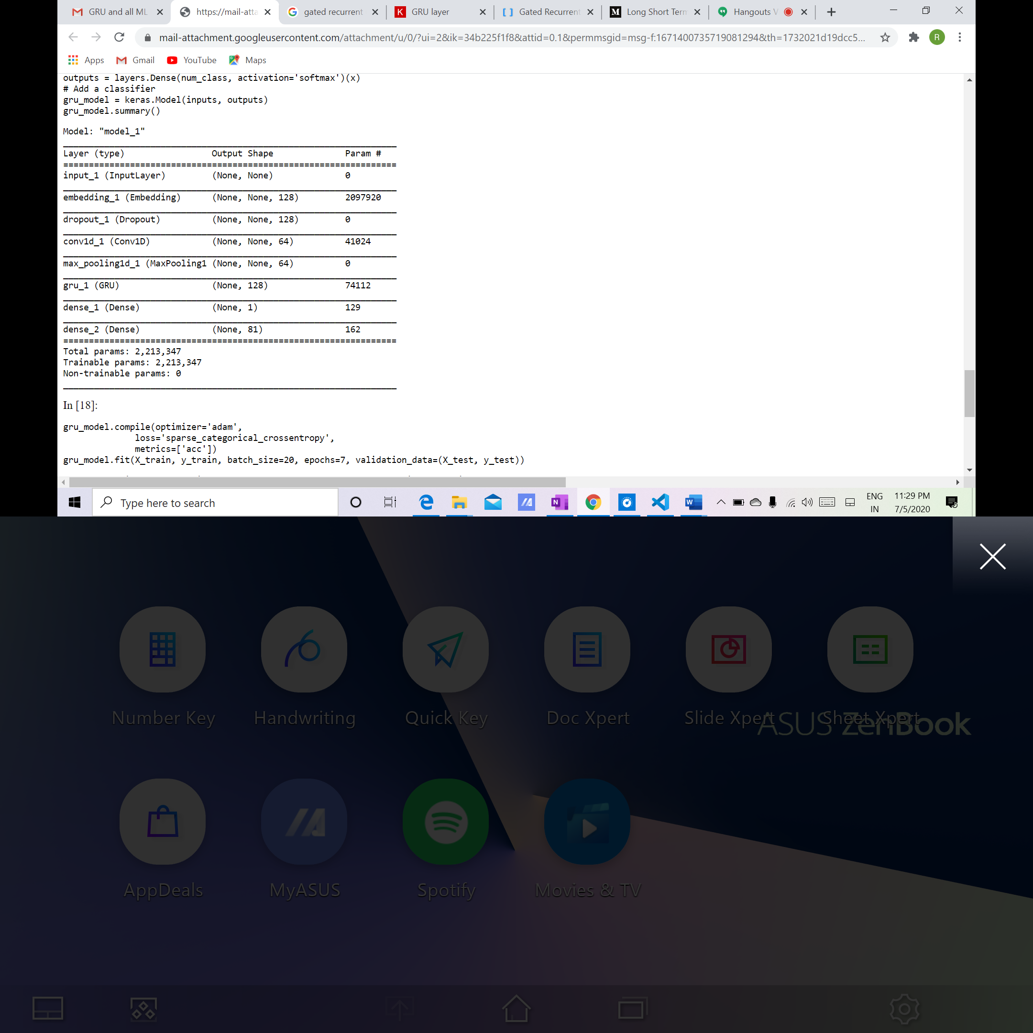

**Model Performance:**

GRU accuracy is very poor(~10.94%) and hence, it is not suitable for our ticket generation application.

### Attention Mechanism

Given the tendency of RNNs to forget relevant information in the previous steps of the sequence, this could lose some of the useful information encoded there. In order to keep that information, we can use an average of the encoded states the RNN outputs. Since all these encoded states of the RNN are equally valuable, we use a weighted sum of these encoded states (i.e., our Attention mechanism) to make our prediction.

**Model Summary:**

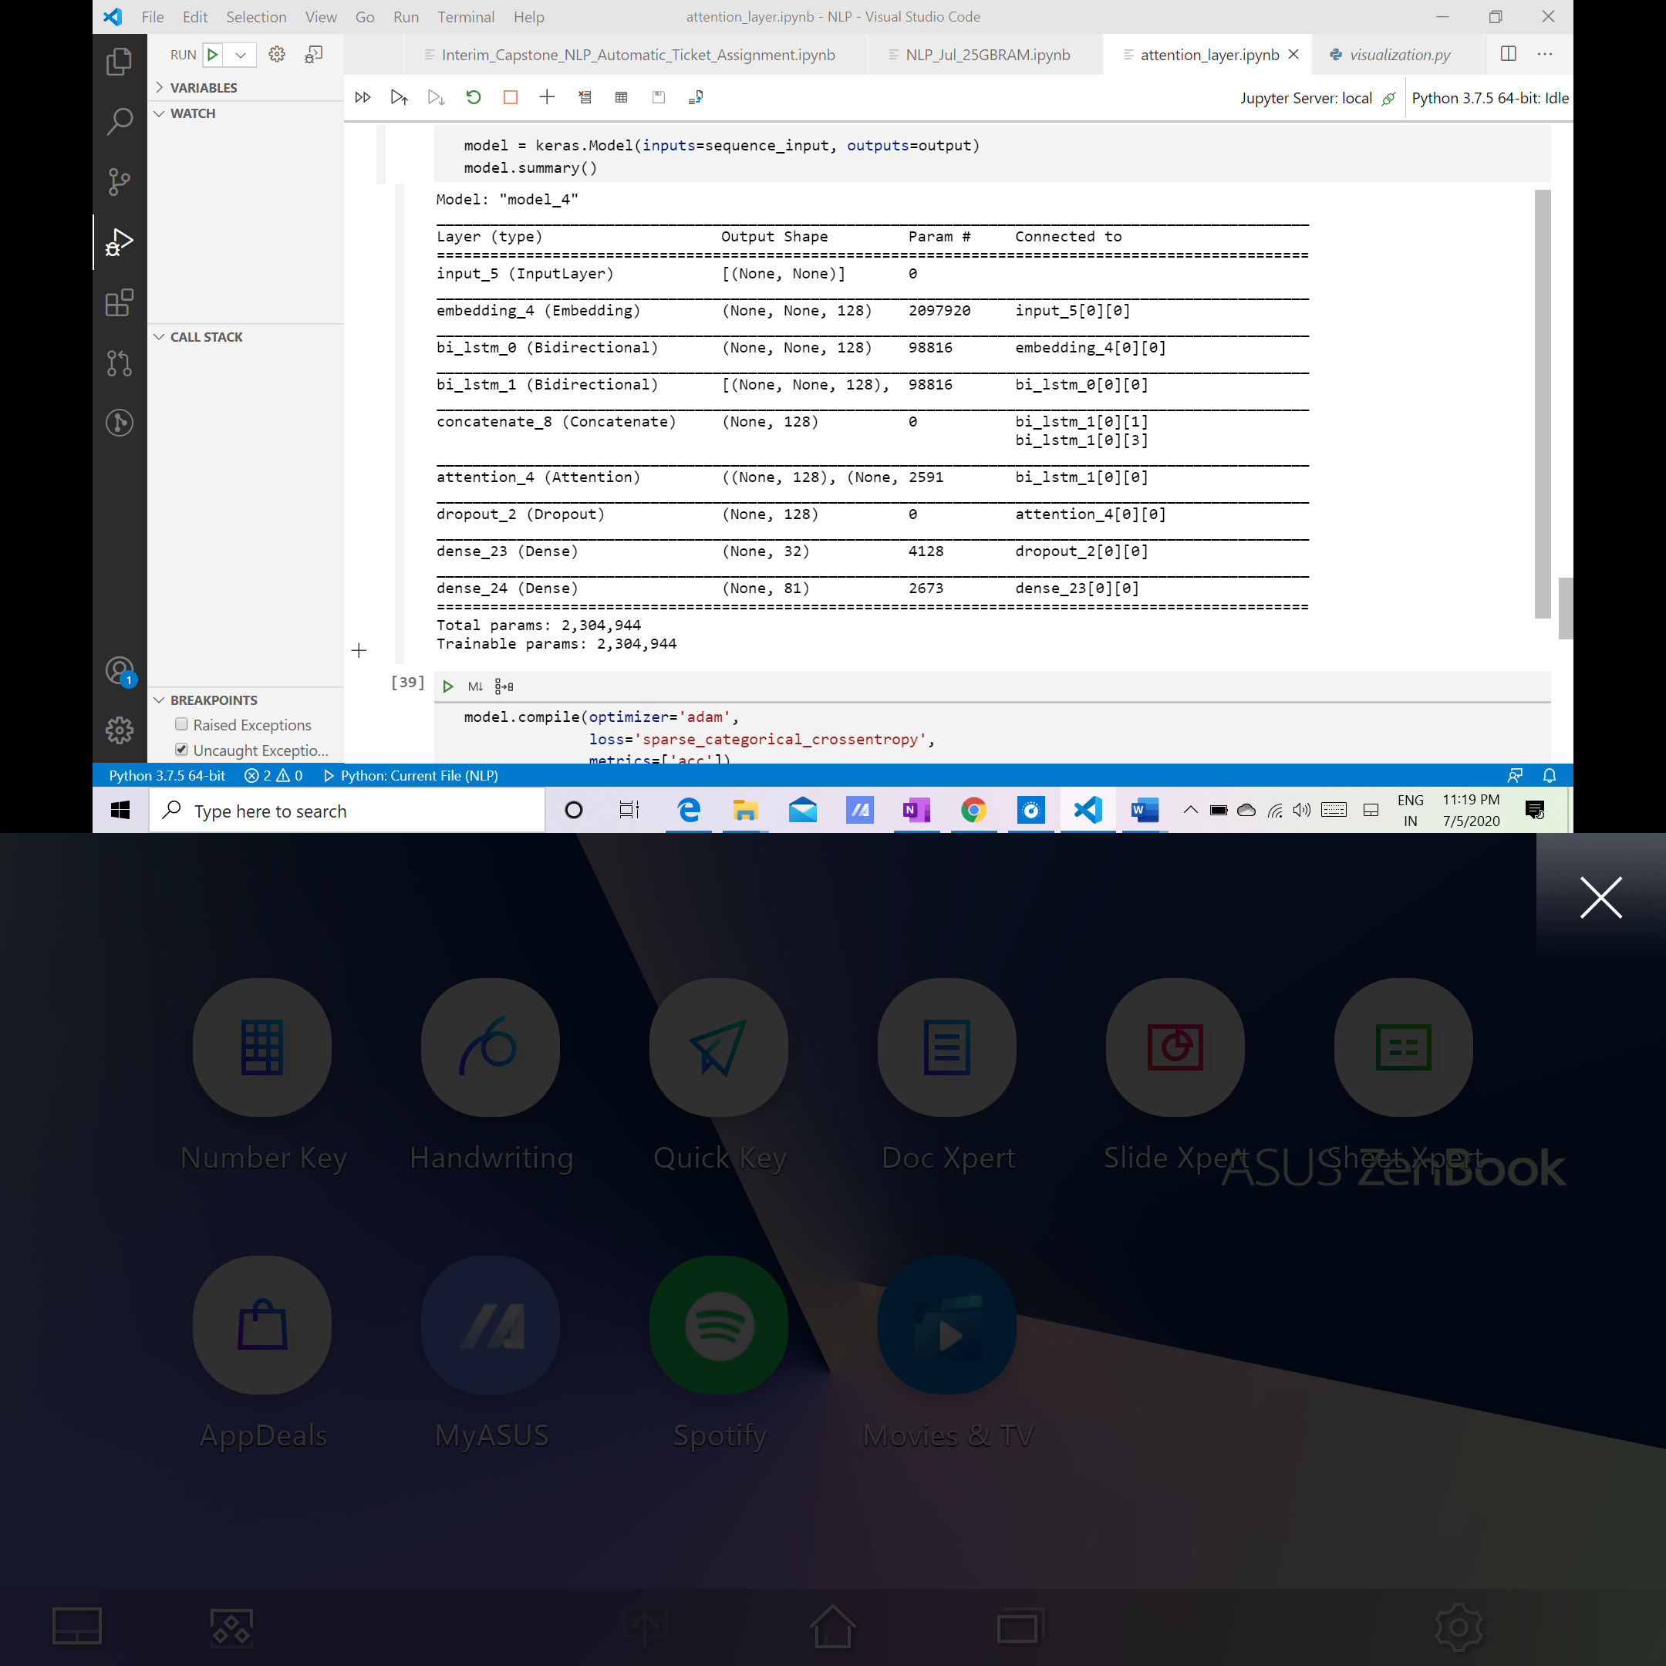

**Model Performance:**

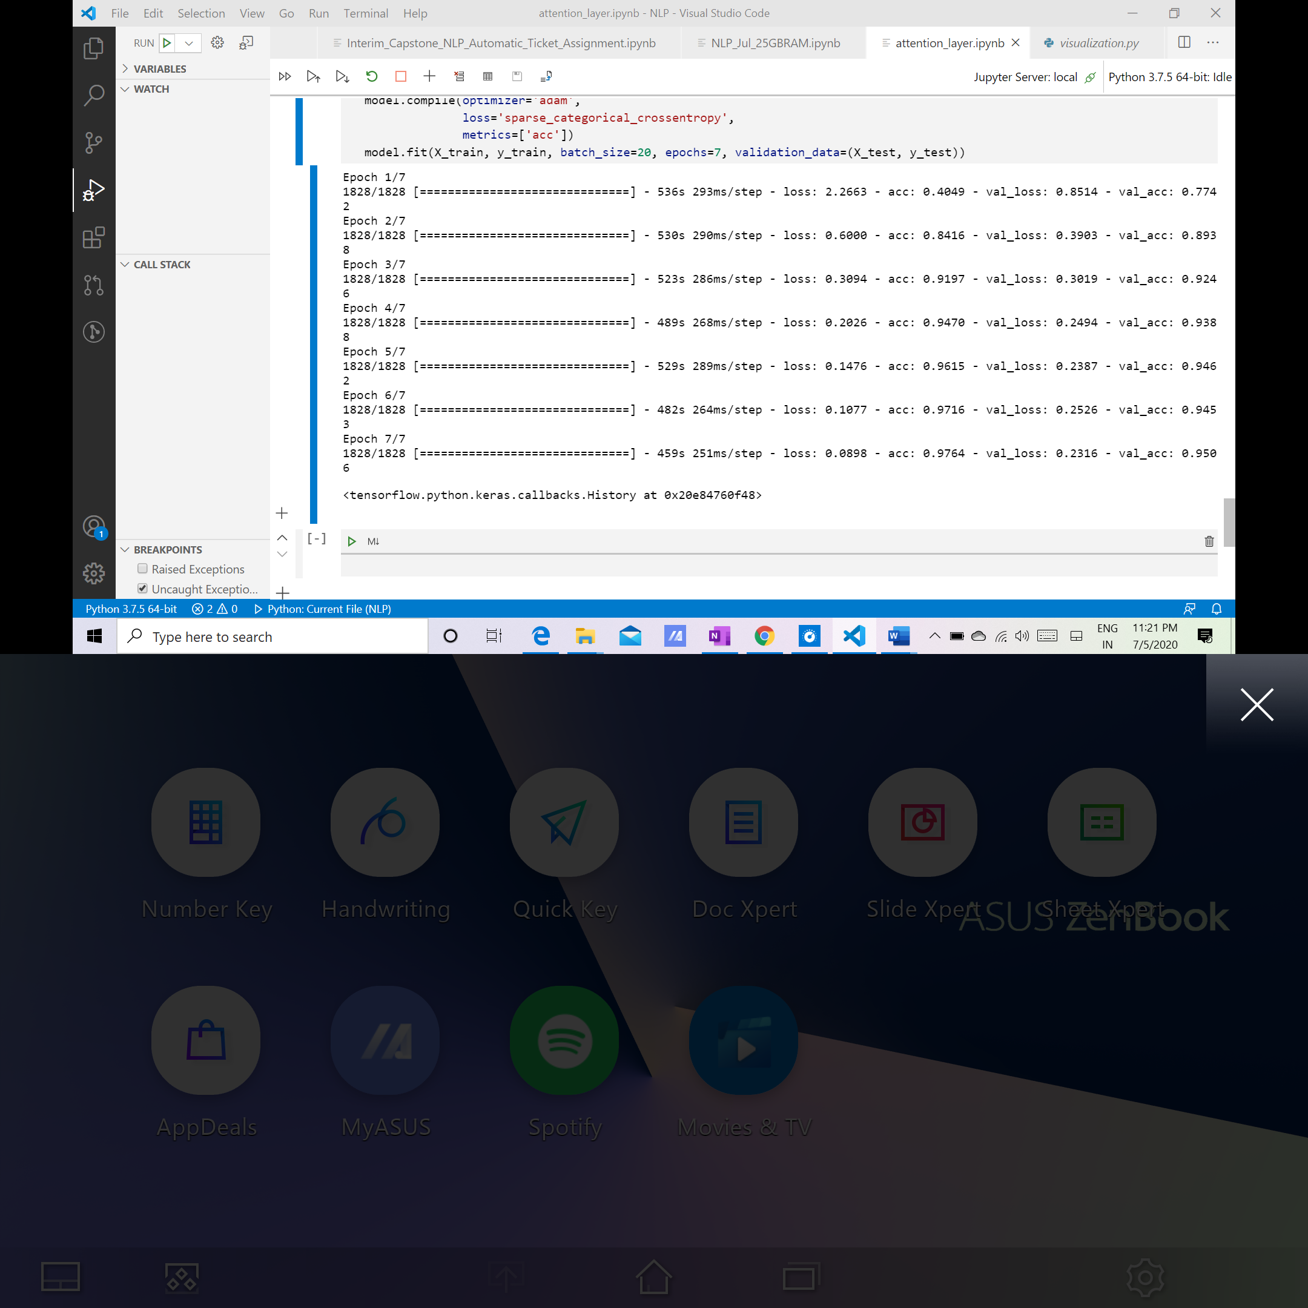

# Model evaluation

Describe the final model in detail. What was the objective, what parameters were prominent, and how did you evaluate the success of your models?

|  |  |  |  |  |
| --- | --- | --- | --- | --- |
|  | **SVC** | | **LightGBM** | |
|  | **Accuracy** | **F1-Score** | **Accuracy** | **F1-Score** |
| **BoW** | 94.72% | 0.9441 | 96.33 | 0.9615 |
| **Tf-Idf** | 92.41% | 0.9213 | 96.2 | 0.960 |
| **Topic Modelling** | 92.41 | 0.9213 | 96.19 | 0.960 |

|  |  |
| --- | --- |
| **Model** | **Accuracy** |
| LSTM | 92.8% |
| Bi-LSTM | 94.56% |
| GRU | 10.94% |
| Attention Layer | 95.06% |

**Conclusion:**

**As per our analysis the best performing model with highest accuracy is BoW+ LightGBM which is giving us 96.33% of accuracy with the F1 score of 0.9615. Hence, this model for ticket assignment based upon available dataset.**

**Remark: We will switch to deep learning RNN models like Attention Layer and Bi LSTM if we will have the access to a much larger dataset compared to the current one.**

# Comparison to benchmark

*How does your final solution compare to the benchmark you laid out at the outset? Did you improve on the benchmark? Why or why not?*

# Visualizations

In addition to quantifying your model and the solution, please include all relevant visualizations that support the ideas/insights that you gleaned from the data.

**Data Distribution:**

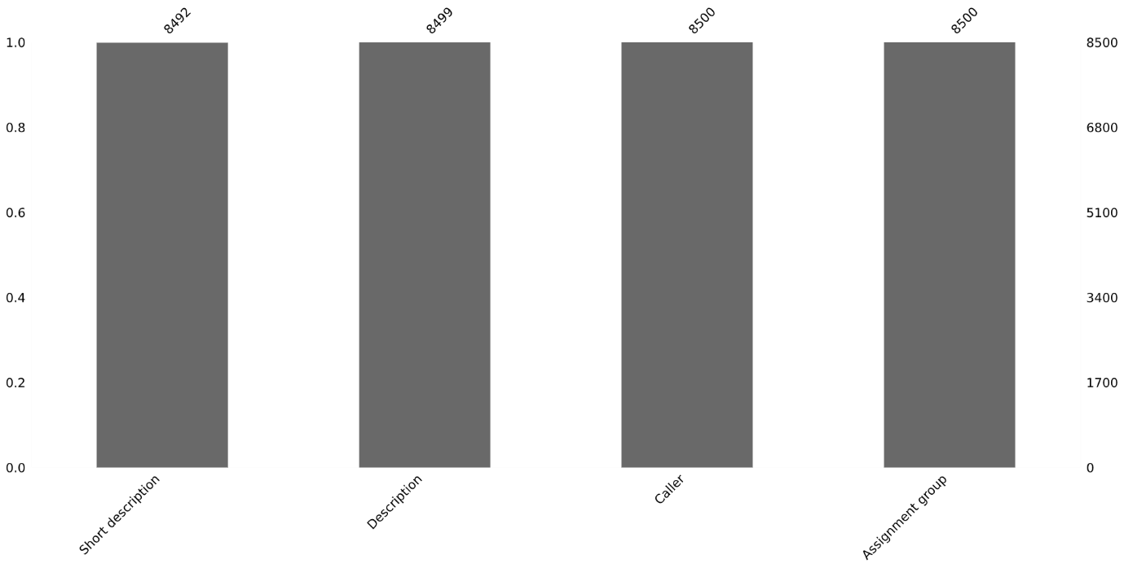

**Word Cloud for Short Description:**

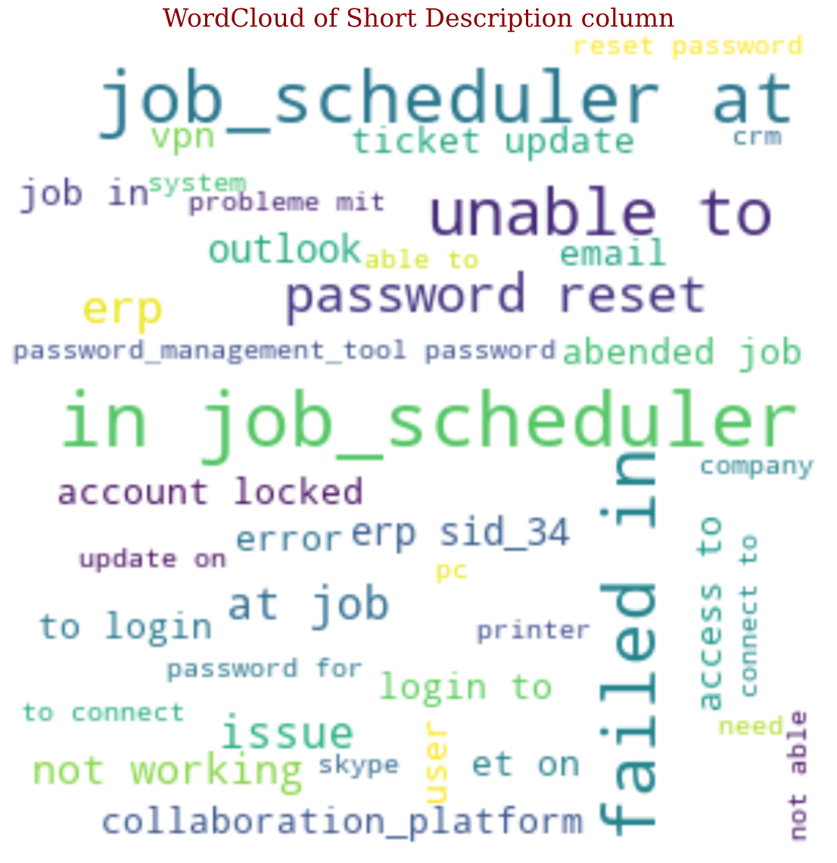

**Word Cloud Description:**

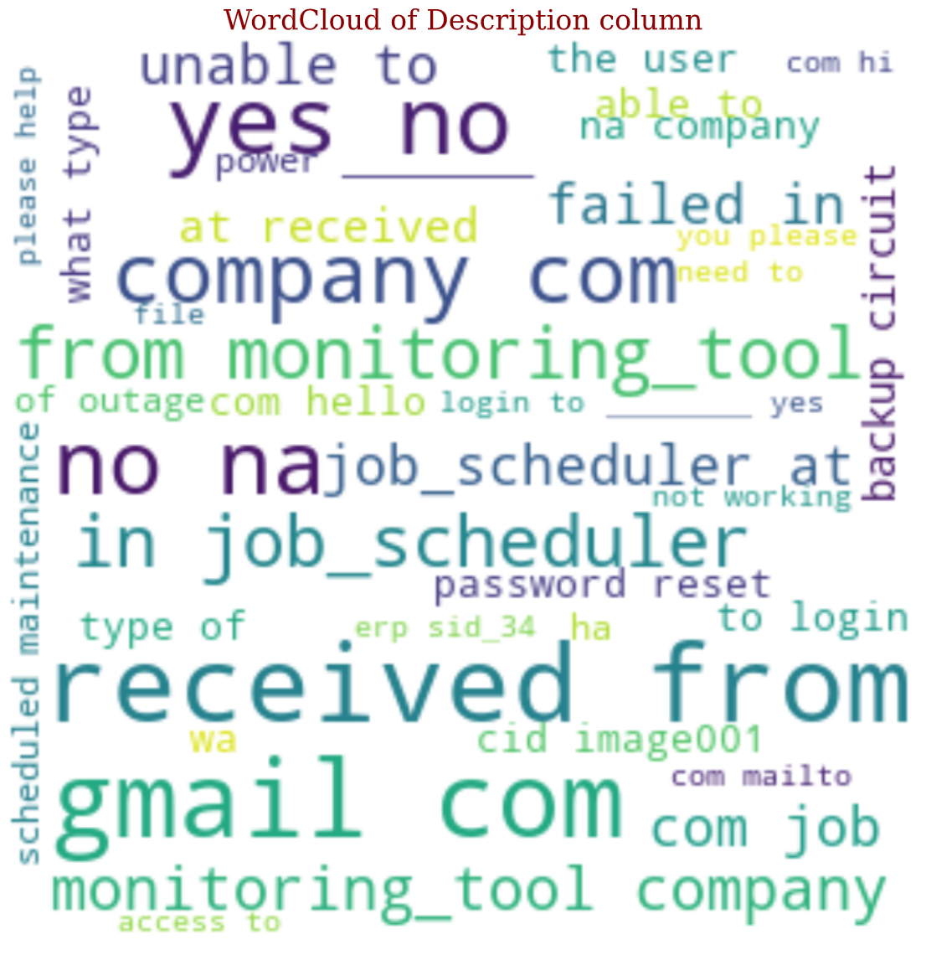

**Distribution of tickets in different groups:**

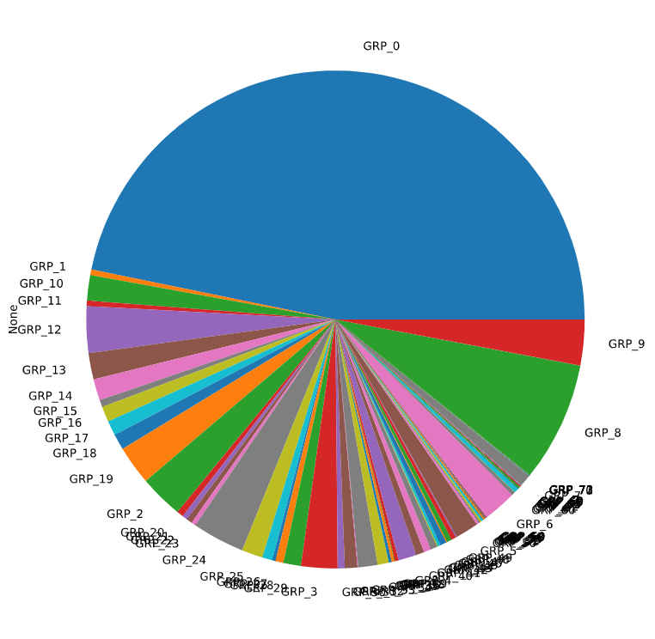

**Ticket Distribution in various groups using matplotlib:**

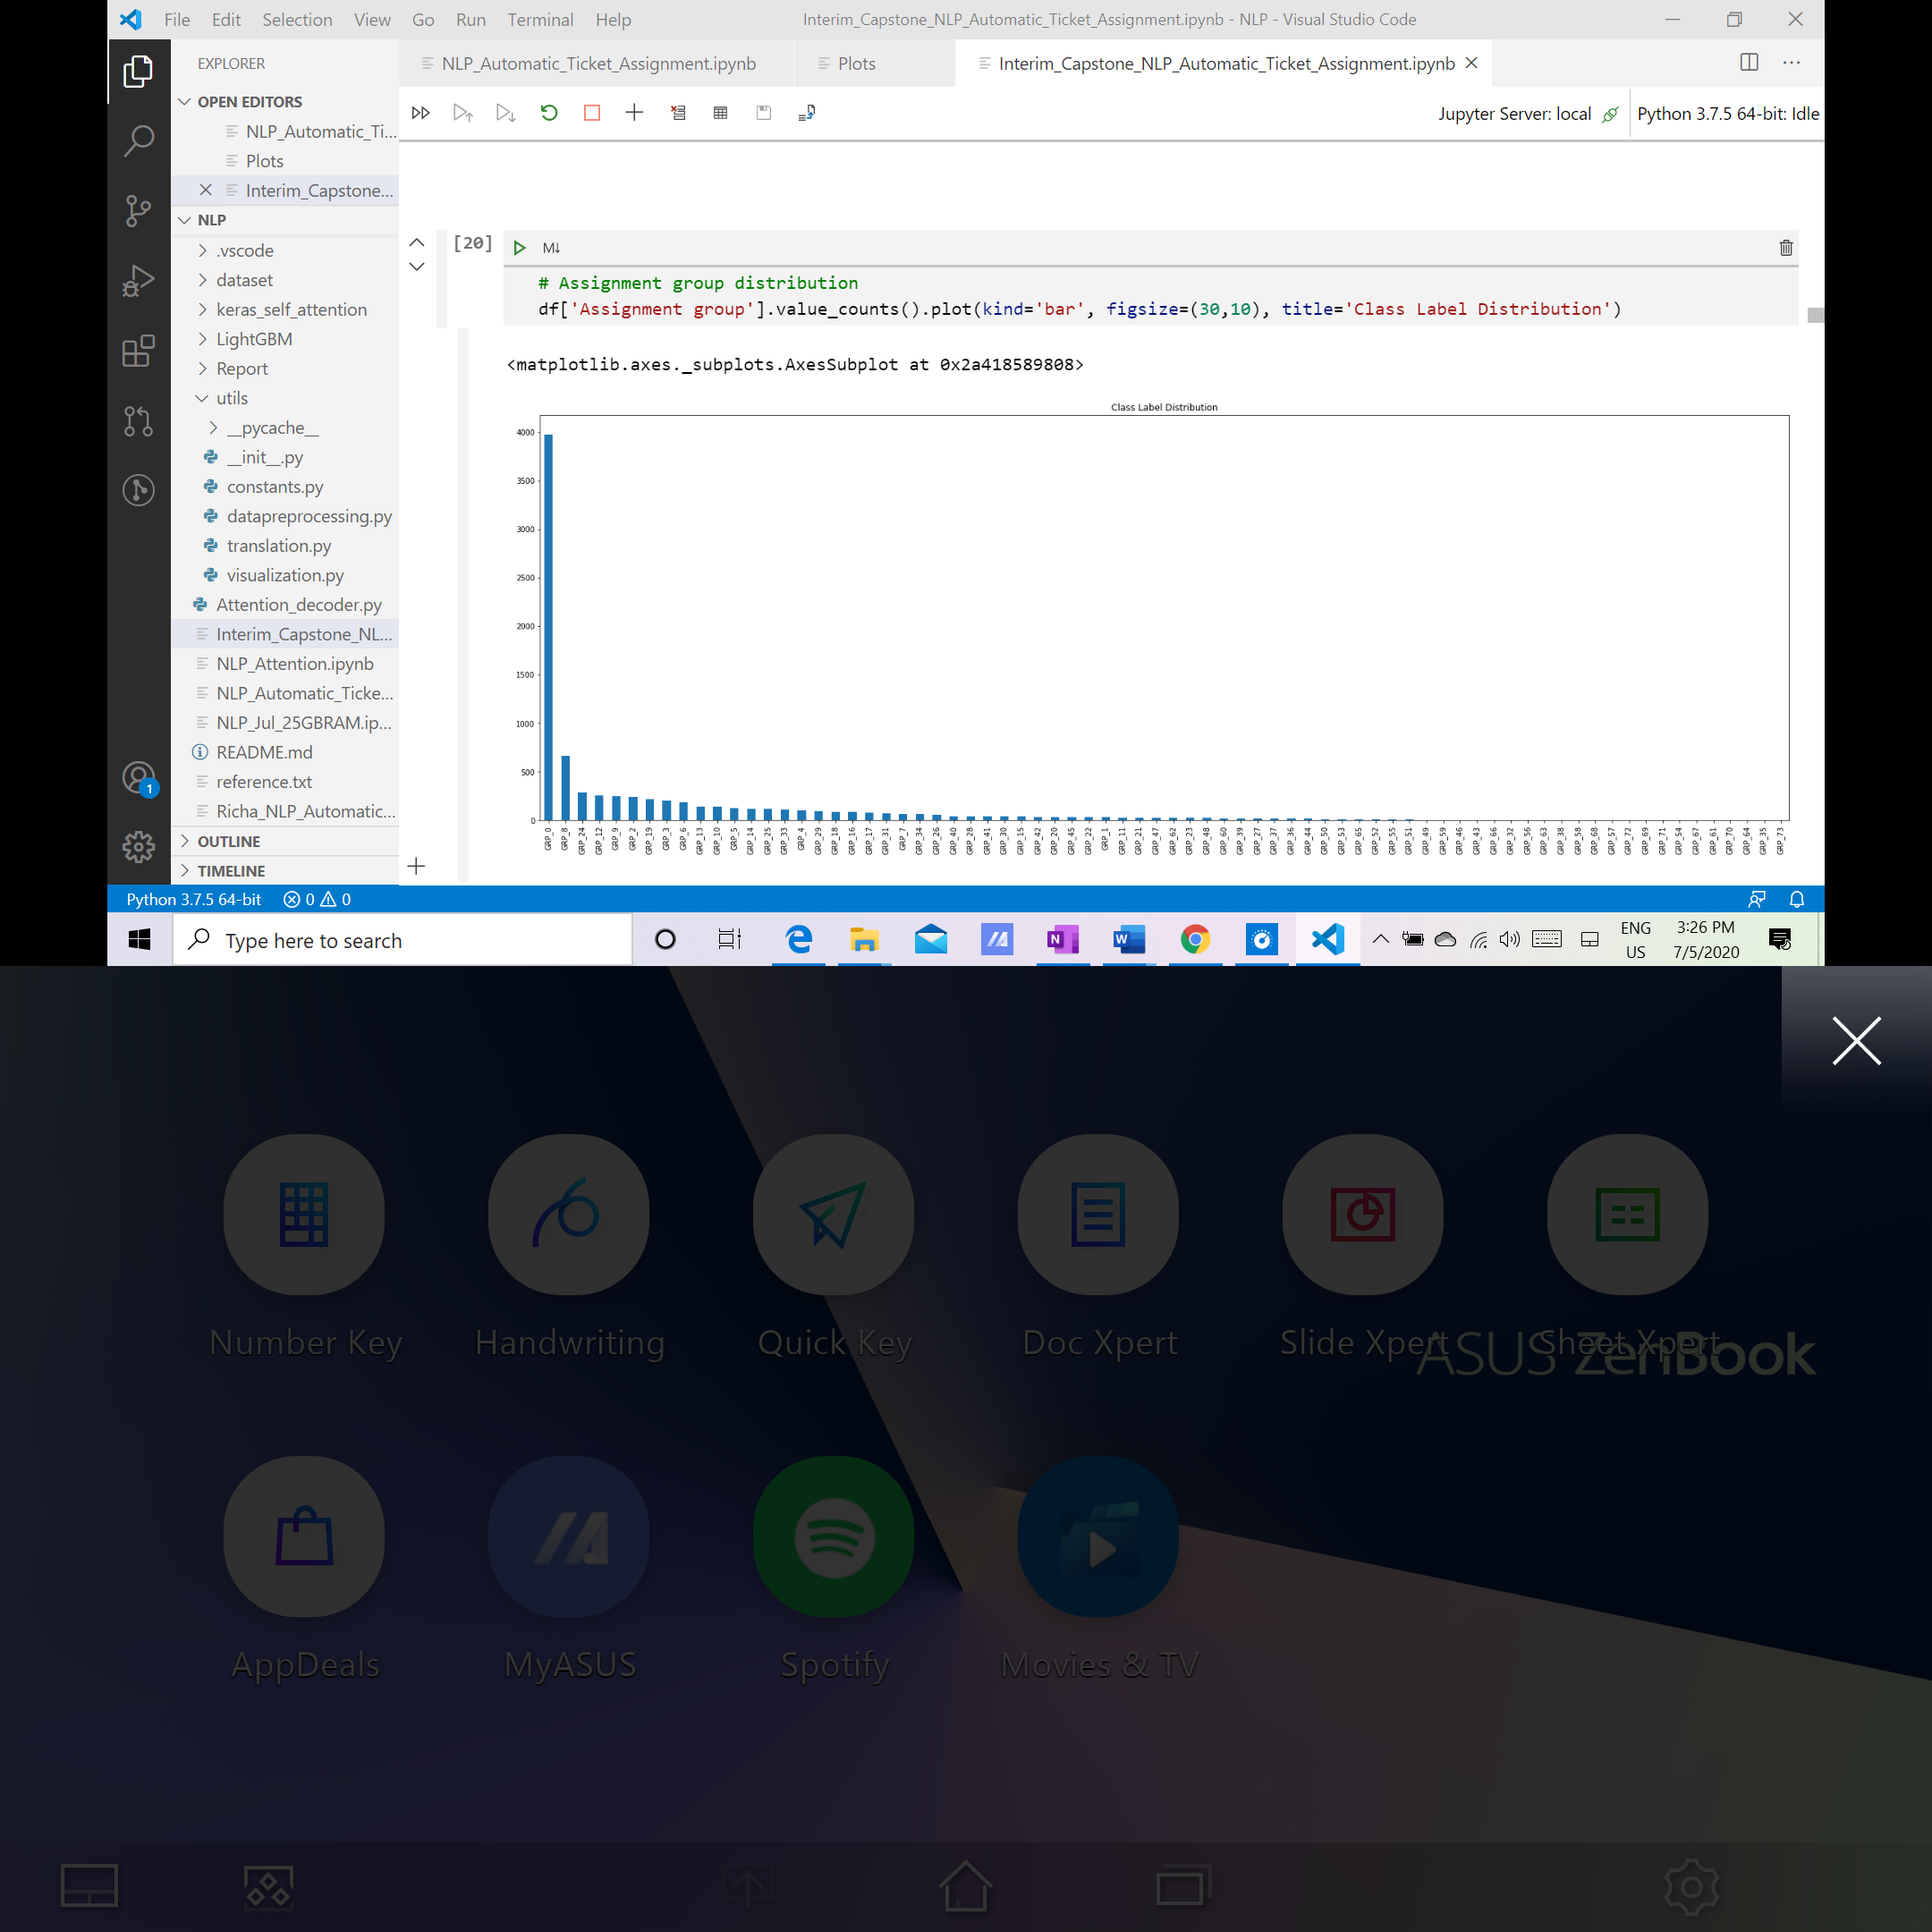

**Visual Analysis of Change in Assignment Group Distribution before and After Upscaling+Subgrouping GRP_0:**

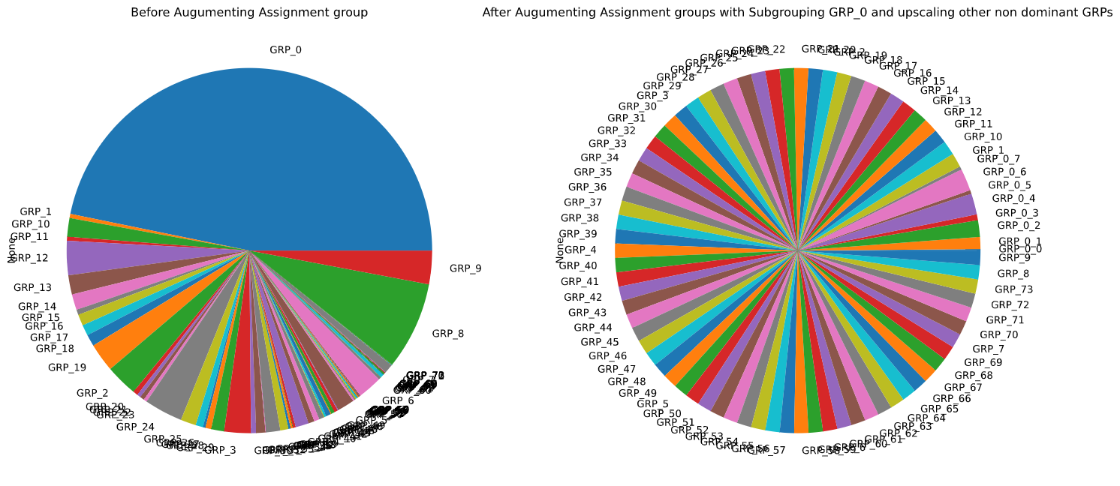

# Implications

*How does your solution affect the problem in the domain or business? What recommendations would you make, and with what level of confidence?*

In the digital era everyone is relying on the technology and expecting quick resolution to the problems. In order to meet customer expectations, the L1/L2 IT staff is overwhelmed with the work, and hiring more resources is not going to solve the problem. As volume of tickets will continue to increase, AI-led solutions are the need of hour.

Our NLP model can process request like a human agent by reading the ticket description to make sense of text data before categorizing the ticket to any group.

The Bidirectional LSTM model has around 93% accuracy and the precision will increase over time with continuous training.

This solution when integrated with the ticket management workflow will also help to increase customer satisfaction as tickets will be automatically sent to the right person (L2 Team), instead of being passed from one agent to the next, and responses and resolutions can be completed more accurately and faster while [reducing customer effort](https://medium.com/help-scout/how-to-eliminate-high-effort-customer-experiences-9cd0c226ec1f). Our solution can act as a potential replacement for L1 Team. Hence, saving both manpower and time for the organization.

Also, the ticket categorization and allocation can work 24/7 so if an urgent ticket is logged our machine learning models can deal with them as quickly as possible.

This approach will also help in reducing human errors as learning applied by the models will be used in ticket classification and hence increase the accuracy of the process.

# Limitations

*What are the limitations of your solution? Where does your model fall short in the real world? What can you do to enhance the solution?*

The dataset used for the analysis have only 8500 records. We have applied deterministic rules, up sampling and clustering techniques to prepare the data which has been used to train and test the model. If this solution is implemented directly in production then with there is a possibility that it will not give the desired outcome.

We would have to work with Business Owners to first understand the real-world scenarios in which these tickets are handled and categorized. The deterministic rules will be validated by the SMEs and will be implemented first to identify the prediction by the solution.

Our next step would be to gather the enough and right set of data from the Business Owners and validate our models. If needed we will tweak our models to ensure that they deliver the desired results and outcomes are as per the business needs.

# Closing Reflections

What have you learned from the process? What you do differently next time?

Key Learnings:

1. Use deterministic rules to eliminate the data which will not contribute much in machine learnings and will increase the overhead. In our problem statement we got better results without using deterministic rule-based predications.

2. When and how to apply clustering and up sampling techniques

3. Focus on data visualization and pre-processing techniques which are being applied and validate the results

# Flow Chart

